

Fred - Simple Smart and Swift ECM

User Guide Version 3.3



Document reference: Fred/user guide/3.3

Trial Version: 3.3

Document revision: 1.0

Release date: 1/11/2015

**Copyright**

Copyright 2015, by XeniT Solutions and others.

Information in this document is subject to change without notice.

If you need technical support for this product or if you have comments, suggestions or questions about this documentation or product, contact us at [fred@xenit.eu](mailto:fred@xenit.eu).

TABLE OF CONTENT

1 About Fred 1

2 What is new in Fred 3.3 1

3 Installation requirements 1

4 Installation instructions 1

5 How to upgrade 1

6 About document models and metadata 1

7 Getting started 1

8 Connecting to Alfresco 1

9 Alfresco access control 1

10 Browsing the repository 1

10.1 Navigating the folder structure 1

10.2 Using the Address bar 1

10.3 Back and forward and navigation history 1

10.4 Favorites 1

10.5 My Sites (New) 1

10.6 My saved searches 1

10.7 Documents I am editing 1

10.8 Hiding folders in the navigation PANE 1

10.9 Opening multiple browser tabs 1

11 Handling folders 1

11.1 Refresh 1

11.2 Create folders (New) 1

11.3 Rename folders 1

11.4 Metadata of folders 1

11.5 Move folders 1

11.6 Delete folder 1

11.7 Copy folder link 1

11.8 Copy Fred Link 1

11.9 Create a New document 1

11.10 Show Folder in Alfresco browser 1

11.11 Print documents 1

11.12 Paste into folder 1

11.13 Paste as shortcut 1

11.14 Folder permissions 1

11.15 Multi folder functionality 1

12 Taking content offline 1

12.1 Selecting the content you want to take offline 1

12.2 Refreshing offline coNtent 1

12.3 Deactivating Offline sync 1

12.4 Working in Offline mode 1

13 Adding content to and getting content from the server 1

13.1 Uploading fileS 1

13.2 Uploading folders 1

13.3 Compress documents and folders to a container on your local drive 1

14 Handling Documents 1

14.1 Open document 1

14.2 Document metadata 1

14.3 Move document 1

14.4 Copy Document 1

14.5 Copy a file link 1

14.6 Copy a Fred Link 1

14.7 Mail as attachment 1

14.8 Send document link via Email 1

14.9 Rename file 1

14.10 Delete files 1

14.11 Refresh metadata 1

14.12 Locking, Check-out and check-in documents 1

14.13 Edit offline 1

14.14 Edit online (NEW) 1

14.15 Pushing metadata from the Alfresco server into Office documents 1

14.16 Word Add-in 1

14.17 Convert to PDF 1

14.18 Preview document (Enhanced) 1

14.19 Enable versioning 1

14.20 Show version history 1

14.21 Compare WORD documents 1

14.22 Show File in Alfresco browser 1

14.23 File permissions 1

14.24 Multi document functionality 1

14.25 Using shortcuts 1

15 Handling metadata 1

15.1 Viewing METADATA of folders 1

15.2 EDIT METADATA of folders 1

15.3 Viewing Document metadata 1

15.4 Edit Document metadata 1

15.5 Auto completion of metadata values (SOLR) 1

15.6 Viewing metadata of Multiple documents 1

15.7 Editing metadata of Multiple documents 1

15.8 Exporting metadata 1

15.9 Metadata governance – Mandatory metadata 1

15.10 Easy integration with third party metadata applications 1

16 Handling views 1

16.1 Show columns 1

16.2 Show a set of Columns 1

16.3 Creating personal views 1

16.4 Sort on columns 1

16.5 Zoom 1

16.6 Virtual views 1

17 Searching 1

17.1 Simple search 1

17.2 Dropping an Alfresco Link or Fred link in the Search field 1

17.3 Advanced search 1

17.4 Facetted search (Enhanced) 1

17.5 AND, OR and () operators in text fields 1

17.6 Messages in search result 1

17.7 Search in a part of the tree structure 1

17.8 Saved Search 1

17.9 Preview your search 1

17.10 Grouping on metadata values 1

17.11 Open file location 1

18 Workflow 1

18.1 Starting a workflow 1

18.2 Workflow overview 1

18.3 My Tasks 1

18.4 Editing a task 1

18.5 Overview of the documents 1

18.6 workflows I’ve started 1

18.7 Cancelling a workflow 1

19 Additional user functions 1

19.1 New Browse Tab 1

19.2 Recycle bin 1

19.3 Browse as user 1

20 Fred User Settings 1

20.1 General 1

20.2 Connection 1

20.3 Advanced 1

21 Enterprise configuration capabilities 1

21.1 Configuration of metadata panel 1

21.2 ConfigurAtion of context menus 1

21.3 Configuration of searchable properties 1

21.4 Configuration of metadata behavior at creation of documents 1

22 General 1

22.1 Showing 3rd party Alfresco Add-ons in Fred 1

22.2 local persistent caching 1

23 Reporting a problem 1

Fred User guide

# About Fred

Fred is a desktop window to Alfresco. Fred is complementary to the Alfresco web interfaces and brings the central document repository closer to your desktop working environment.

Fred looks like Explorer and acts like Alfresco. Making Enterprise Content Management (ECM) intuitive and fast is Fred’s aim. The most commonly-used document actions are now available in a working environment commonly familiar to most users.

Through Fred, you will easily be able to enter multiple documents into Alfresco or locate and open documents from Alfresco. As long as you have an internet connection, you will be able to work remotely, using Fred; it enables performance and productivity, wherever you are, using the same user interface.

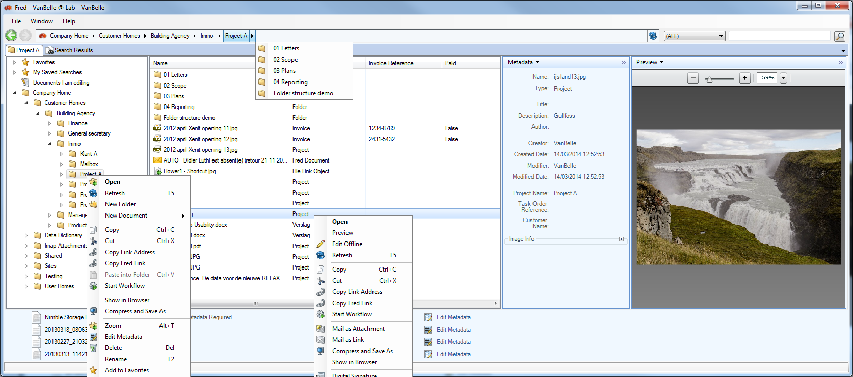

*Navigation Tab in Fred.*

# What is new in Fred 3.3

The following functionalities have been added or modified in this release:

**Handling folders**

* Create folder from template

**Navigation**

* My Sites: similar to My Favorites but for the Share Sites of which you are a member

**Alfresco 5.0 support**

* Edit online of MS Office documents
* Enhanced previews with search in preview
* Support of SOLR 4 – enhanced search capabilities

# Installation requirements

Minimum requirement for installing Fred are:

* OS: Vista SP2, Win 7 SP1 or higher
* .NET Framework 4.5
* 90 Mb of available disk space: initial installation and first server

For Outlook 2003 integration: PIA 2003 - Primary Interop Assemblies

For Edit Online: MS Office 2011 or higher

Convert to PDF: MS Office 2007 or higher

Compare documents: MS WORD 2007 or higher

Metadata auto completion: requires SOLR-based search on the Alfresco server

Facetted search: requires SOLR-based search on the Alfresco server

# Installation instructions

Contact your system administrator for more information about where you can download the Fred set-up file.

* Download the set-up file to your local disk.
* Open the folder from the fred-trial-setup.exe file download location and double click on it.

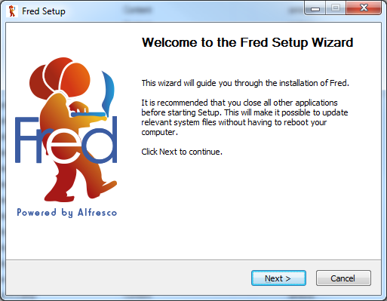

* Click on next.

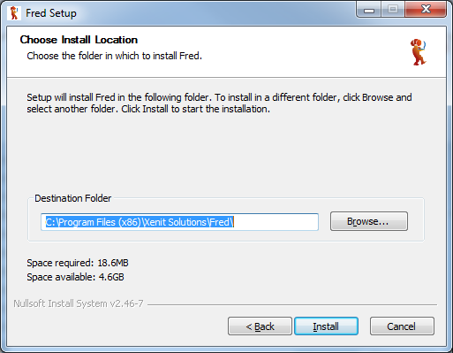

* If you do not want to use the standard setting, browse to the folder in which you want to install the Fred application. Click on “Install”.
* The application is now being installed.

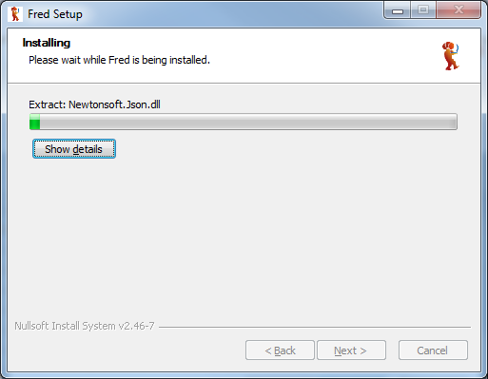

* Click on “Next”.

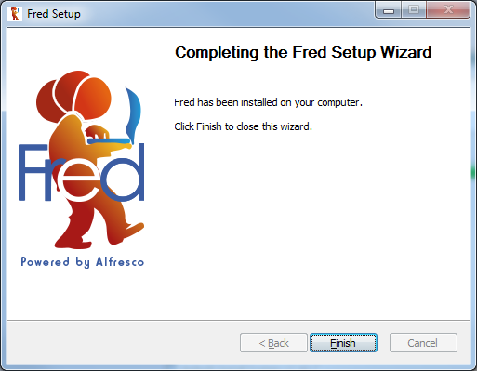

* Fred has been installed. Click on “Finish” to complete the installation process.

In the program menu tree, new commands are now available under the XeniT solutions folder:

* Fred: start the application
* Uninstall Fred: remove the application from your computer

# How to upgrade

New versions of Fred are released on a regular basis. Visit our website regularly to see if new versions are available. Download the new version from the Fred website Online Demos page.

Fred compares the compatibility of the front-end and back-end side and provides a message to the user in case of incompatibility.

**Important:** before starting the upgrade process, make sure you have closed the Fred program by using the Exit command on the Fred icon (right mouse click) menu or clicking the Close button .

# About document models and metadata

In a modern ECM platform, files are enriched with metadata, making it much easier to search, guide and retrieve information from the ECM platform. Metadata can be any kind of information (for example, text, date, numeric and lists) that specifies the content or the status of the file.

In Alfresco, metadata is organized in the following way:

* A number of document types, each having a particular combination of specific metadata fields, are defined. For example: offer, order, invoice, marketing document and contract
* Some metadata fields can appear in multiple document types, for example: customer name
* Metadata can be mandatory or optional, single value or multi value
* Drop down lists can be used to provide pre-defined values for the metadata field
* Constraints can be defined through formatting of field values

The Fred Trial environment provides a sample document model with a variety of document types and metadata field types and constraints. This trial document model will evolve over time to allow you to experience the new functionalities of Fred.

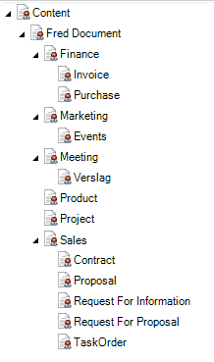

# Getting started

* Click on the XeniT Solutions/Fred command to start up Fred.
* The Fred icon  will appear in the task bar and the Fred window will open.
* Clicking on the Fred icon will open and close the Fred Window.

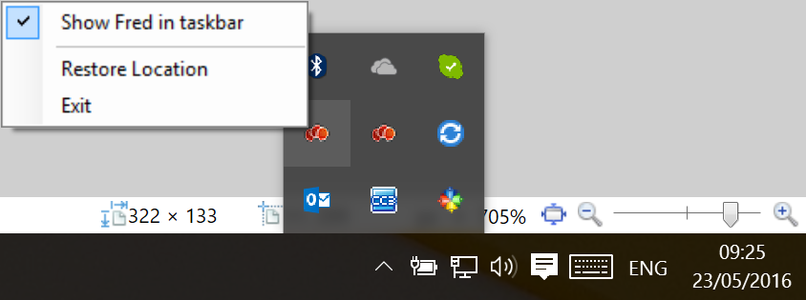

* A right mouse click on the Fred icon pops-up a menu, allowing you to configure the appearance of the Fred application:
* Show Fred in taskbar: presents a Fred tab in the Windows taskbar,
* Restore location: returns the Fred pane back to the standard bottom right corner, and
* Exit: close the application.

The Fred window can be resized, moved, minimized, maximized and closed. Closing the Fred application can be performed using either the Exit command, on the Fred icon menu, the exit command in File/Quit, or the Close button.

# Connecting to Alfresco

The Fred Trial Version has a default server configuration. This Fred Trial Version cannot be configured for another Alfresco server. The user will have to set the username and password as provided by XeniT.

For completeness of this documentation, we are providing you the functional description below.

Fred is a desktop window to the Alfresco Server; that is, Fred presents the content of the Alfresco server to the user. To be able to access the server, the user needs to configure the Alfresco repository to which the user wishes to connect.

The Fred start-up window contains a list of repositories that have been configured by the user.

* To add a repository, click on at the bottom of the list.
* Fill in the fields of the repository you want to configure:
* Repository name: any information to describe the repository,
* Repository type: Alfresco
* Repository URL: the link to the Alfresco repository you want to connect to. Contact your system administrator to receive the link to your Alfresco repository,
* Authentication:
  + Username/password: where there is no Single Sign-on available, you will need to fill in the username and password to authenticate yourself against the Alfresco server.
  + Negotiate (SSO)
  + Negotiate with credentials
  + NTLM (SSO): use Single Sign-on authentication in a corporate network, and
  + NTLM with Credentials
* Click save.

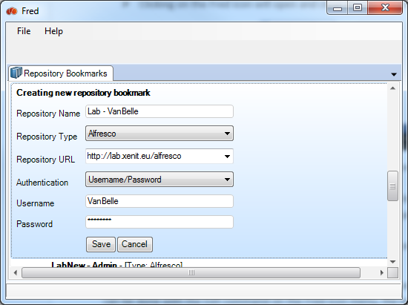

Now this repository will be included in the list of all the repositories you have configured. You can connect to multiple repositories, using multiple account names.

The list of repositories you have configured are sorted alphabetically based on the repository names you have provided.

In the list of repositories, you can select one repository to be the default repository. When you start up Fred, it will open the default repository immediately. If no default repository is selected, then Fred will open the repository list at start-up.

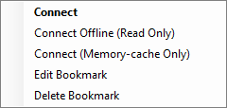

* To enter a repository, you need to double click on a repository within the list.
* When you have previously entered an Alfresco repository, and you want to move to another repository, click File/Disconnect .
* Click on Edit Bookmark to modify the configuration settings of the bookmark.
* Click on Delete Bookmark to remove a bookmark from the list
* Click on Connect Offline when you are not connected to the internet and you want to navigate to the part of your repository that is in the local cache.
* Connect (Memory-cache Only): this is a technical option which might be used upon request of your help desk.

# Alfresco access control

Fred does not provide extra access control on top of the Alfresco functionality. Fred is fully transparent with regards to the access control implemented in Alfresco. Any access rights provided to a user or a group on a folder or a file will be applicable in the Fred application. Therefore, for example:

* you will be able to find and see folders and files for which you have, at minimum, reading rights
* you will be able to create folders when you have collaborator rights or higher
* action commands for which you have permission will be enabled and vice versa action command, for which you have no rights on the selected file or folder, will be disabled.

# Browsing the repository

When you have logged into a specific repository, you will be able to see all folders and files for which you have the appropriate rights.

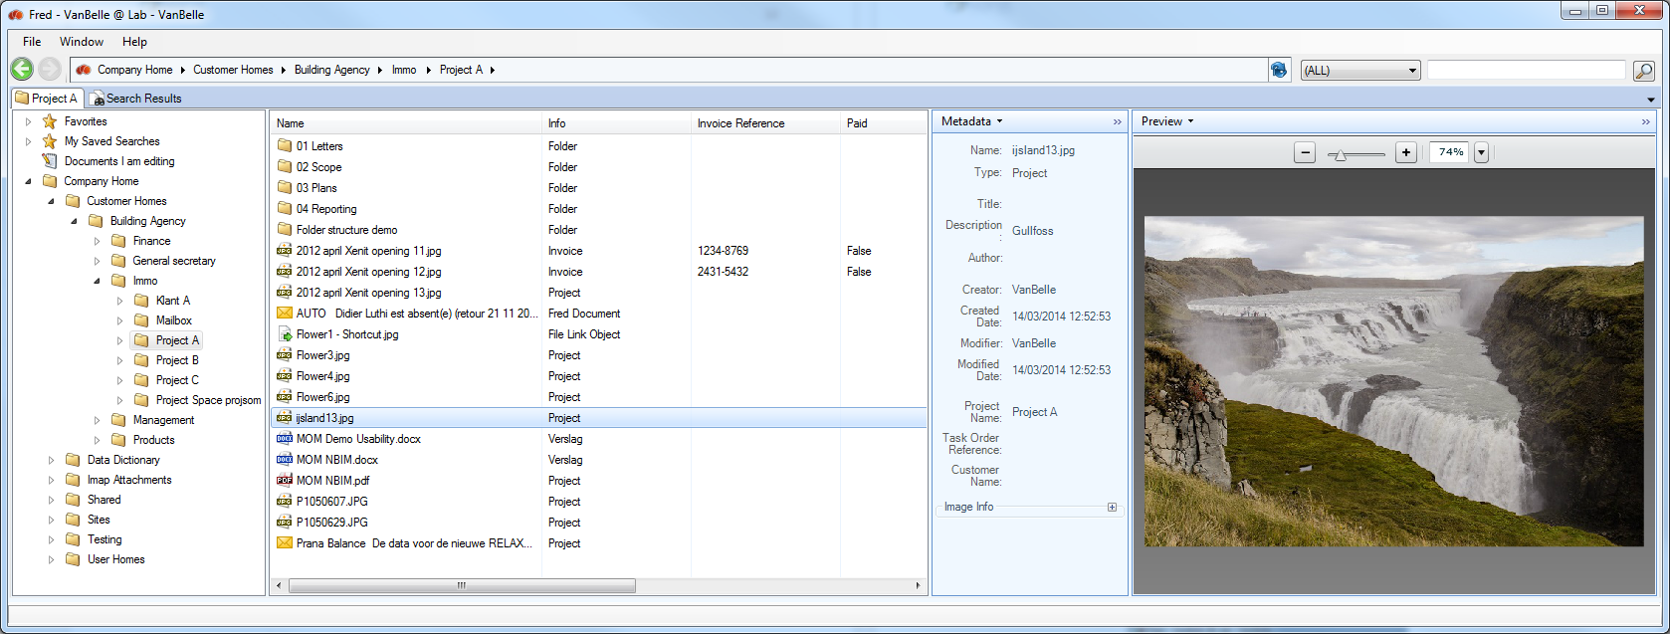

The browser tab has the following elements:

* Address bar, indicating which folder is the active folder
* Navigation pane, presenting the folder structure in the repository
* Details pane, showing the underlying folders and the files in the selected folder. Columns show additional details for the content
* Metadata pane, showing the metadata linked to the selected file or folder in the detail pane
* Preview pane, showing a preview of the file selected in the detail pane
* Search box

The behavior in the Address bar and the Navigation and Detail panes are very similar to the functions in MS Explorer. Therefore, you can navigate selecting folders in the Address bar, clicking folders in the navigation pane or double clicking folders in the details pane.

## Navigating the folder structure

Clicking on the  or  symbol will expand or collapse folders in the navigation pane.

Clicking on a folder in the navigation pane or double clicking the folder in the details pane or selecting “Open” will set that folder as your workspace. The path of the selected folder will show up in the Address bar.

The name of the Browser tab is updated to the name of the selected folder.

Setting a folder as your workspace allows you to work continuously in the selected folder without having to click through the tree structure. Closing the Fred application will not change the workspace folder when you re-open Fred.

Search actions are restricted to your current active workspace.

## Using the Address bar

Clicking on any folder in the Address bar at the top of the page will set the selected folder as the active workspace.

You can use the drop down lists at any location in the path to move to another subfolder in the tree.

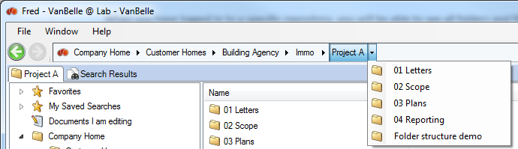

## Back and forward and navigation history

Similar to a Windows interface, you can use the back and forward buttons to browse between previously viewed files and/or folders.

A right mouse click provides a drop down list of previously visited folders.

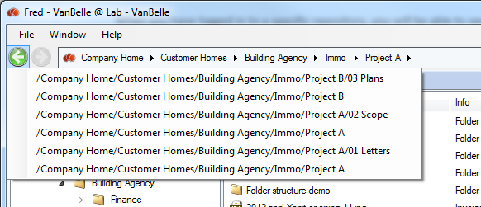

## Favorites

It is possible to add a folder to your Favorites in Fred. You can do this by right clicking on the folder that you want to include as a Favorite, and selecting the “Add to Favorites” option. You can also drag and drop a folder into the Favorites list.

You can rename the folders in the Favorites list by either:

* Right clicking the “Favorite” folder you want to rename, and click “Rename Favorite”
* Using the F2 butt on your keyboard to perform this action
* Clicking a second time on the highlighted folder name

Right clicking on a Favorites folder provides you with the following options:

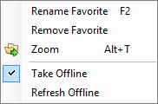 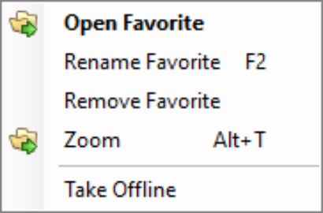

* Open
* Renaming the Favorites will not change the name of the original folder
* You can remove objects from the Favorites list
* You can “Zoom” into the folder
* You can Take Offline the content in your Favorite folder
* You are able to refresh the content and metadata that is already offline

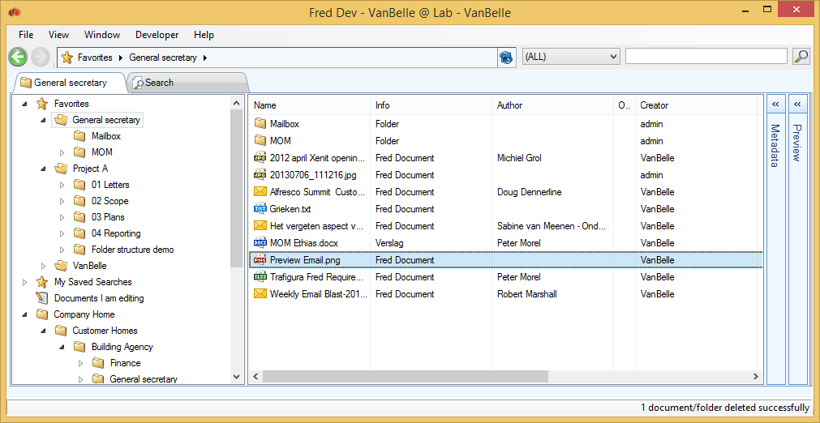

When adding folders to your Favorites, you will be able to navigate into the subfolders of the Favorite folders. As such, the Favorites becomes a full functional personalized folder structure in which you can manage your documents.

You are able to drag and drop documents into your Favorite folder structure. These documents will be uploaded into the appropriate folder.

Note that the breadcrumb at the top will change from the Favorites to the full path indication if you move deeper into the folder structure.

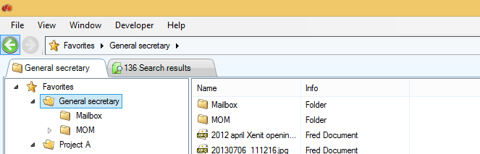

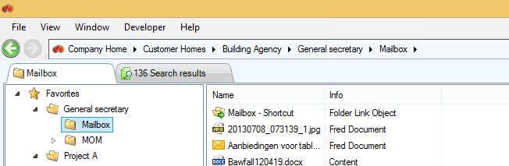

You can start a search query from the Favorite folders. You can launch this from the quick search in the navigation tab or you can select Favorites in the Location field of the Search tab. See also ‘Searching’, for additional guidance using the Search features.

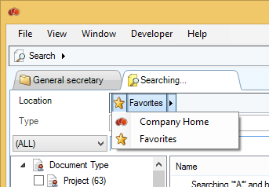

## My Sites (New)

When you are member of a Share Site, the document library of that Share Site will automatically appear under ‘My Sites’. The document library folder will be presented as a folder with the name of the Share Site. For the document library to appear under ‘My Sites’, you need to be a member of the Share Site. Public or Moderated Share Sites will not appear under ‘My Sites’ if you are not a member.

Right clicking a My Sites folder provides you with the following options:

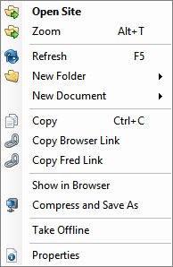

* Open Site will show the details of the folder
* You can “Zoom” into the folder
* You can Refresh the content and metadata
* New Folder option creates a new folder from a folder template
* New Document option creates a new document from a template
* Copy, Copy Browser Link and Copy Fred Link will copy either the content, or the link to a Browser, or the Fred application, onto the Clipboard
* Show in Browser will bring you to the document Library of the Share Site in your default web browser
* Compress and Save will compress the content of the Library and place it onto your desktop
* Take Offline will synchronize the content of the folder on your desktop. This folder will also appear in the Favorites folder (for further information, see ‘Taking content offline’)

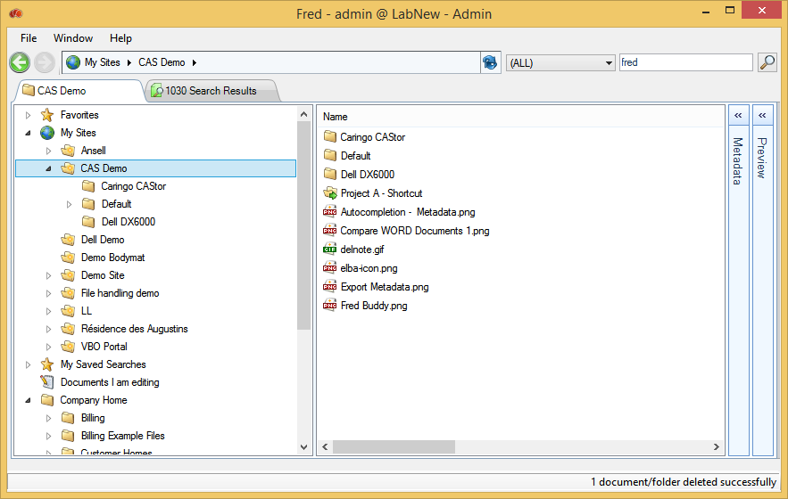

You are able to navigate in the subfolders of the My Sites folders.

You are able to drag and drop documents into your My Sites folder structure. These documents will be uploaded into the selected folder.

Note that the breadcrumb at the top will change from My Sites to the full path indication if you move deeper into the folder structure.

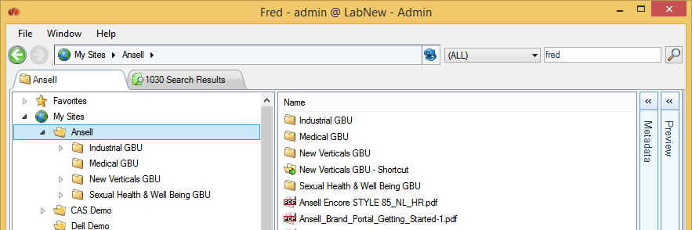

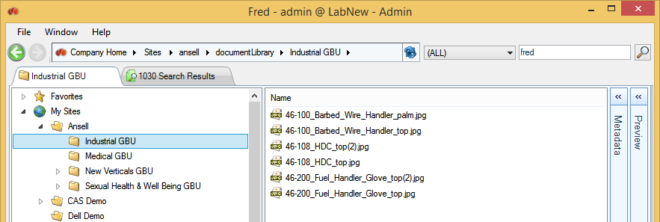

You can start a search query from the My Sites folders. You can launch this from the quick search in the navigation tab or you can select My Sites in the Location field of the Search tab. See also ‘Searching’

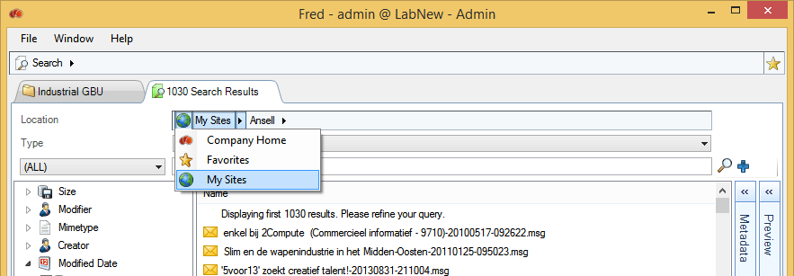

## My saved searches

This folder provides you with a list of all search queries you have saved. Clicking on a search will execute that search again, and present the result in the Search tab.

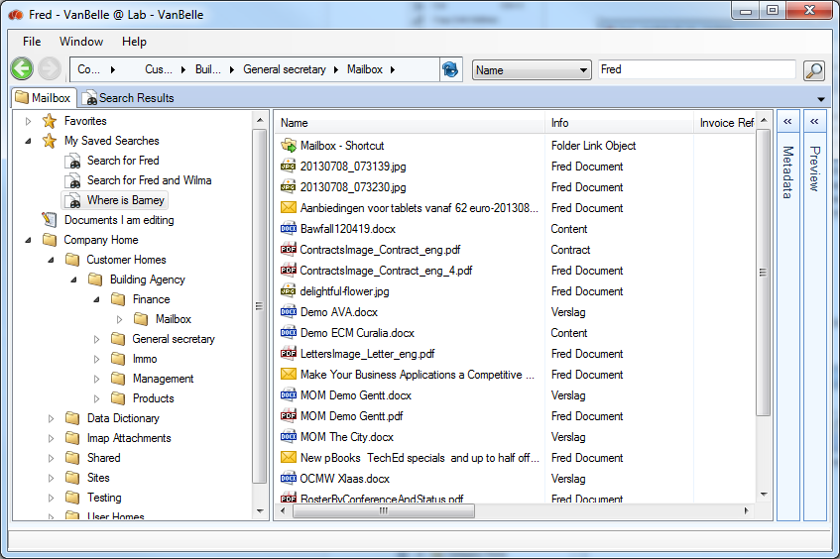

## Documents I am editing

Clicking the ‘Documents I am editing’ option shows in the details pane a list of all the working copies of documents that you have put in Edit Offline mode and have not yet been uploaded.

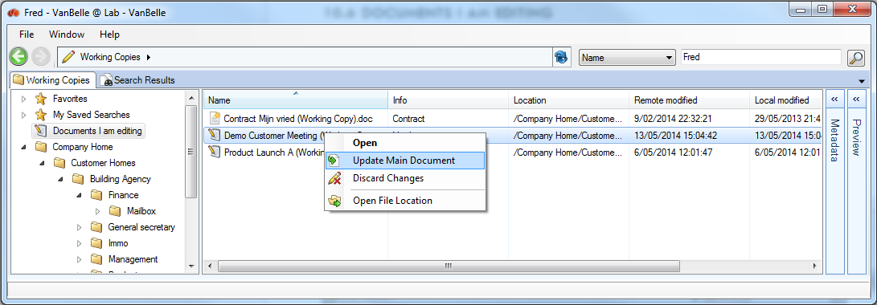

The overview provides you information on the:

* Status of the local copy via an icon
* Modification date of the local and server copy
* Status of the local copy via a message

Using the right click mouse commands, you are able to:

* Open the document
  + If the working copy is already on your PC , it will open the local copy
  + If the local copy is missing , it will download the working copy from the server
* Check-in the document; Fred will take the most recent version of the working copy and check it in
  + The upload progress of the document will be shown in the upload list
  + If the document is versionable, the user will receive a request to specify the new version
* Discard the changes, resulting in the removal of the working copy and the unlocking of the original document
* Open the folder in which the file is located

## Hiding folders in the navigation PANE

It is possible to hide folders such as Data Dictionary and IMAP Attachments in the Fred user interface. These configuration settings are performed on the Alfresco Server and result in:

* The folder not showing up in the navigation pane whilst browsing through the folder structure
* The folder not being displayed in the list of objects in the Details pane
* The folder appearing in the search tab when you launch a specific search for it
* The ability to add the folder as a Favorite or as a shortcut in another folder. This enables you to navigate to the folder if you need to access it

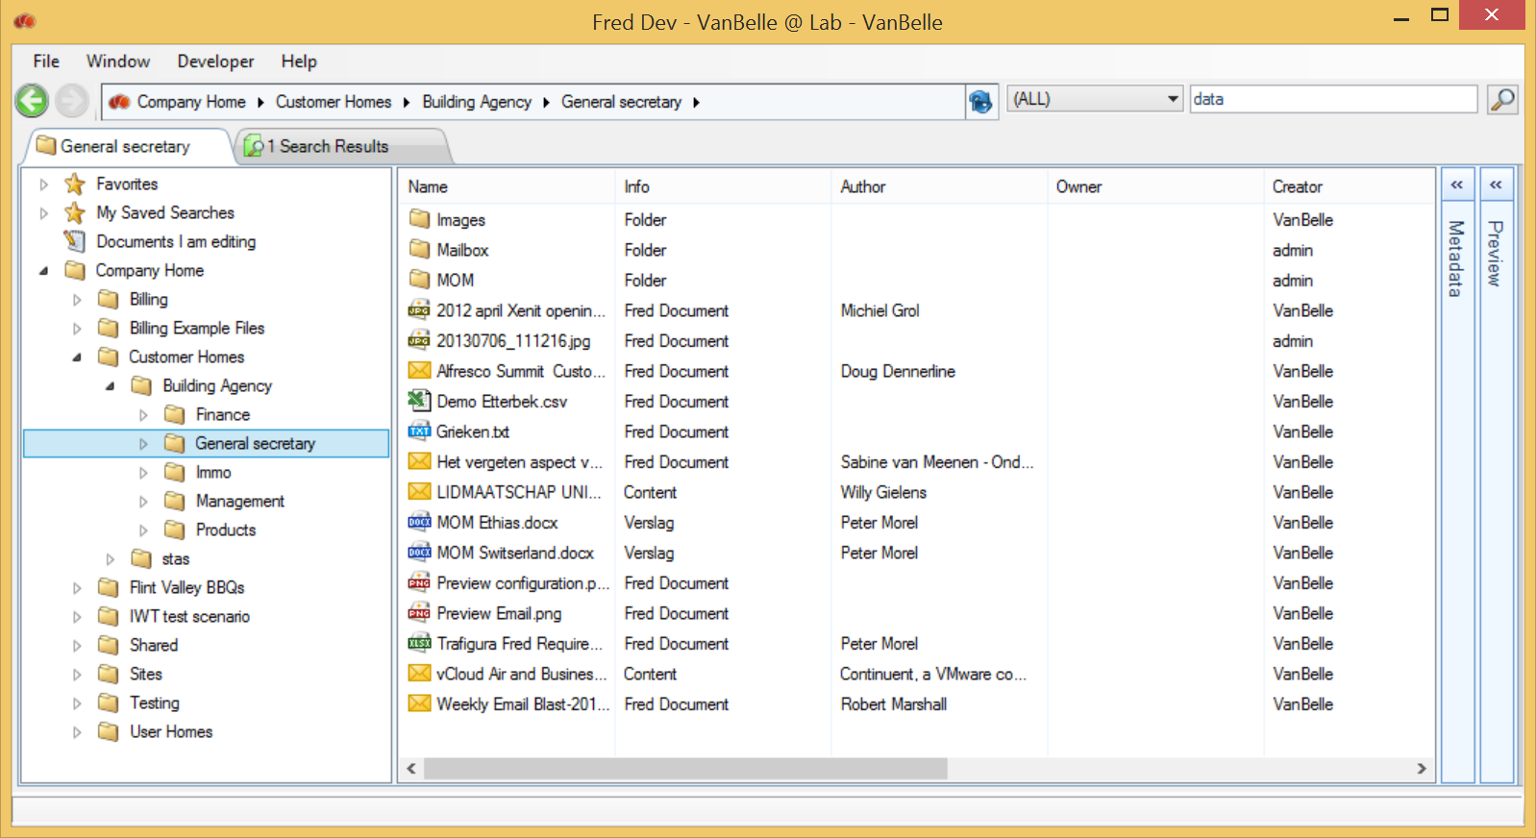

## Opening multiple browser tabs

You can open multiple browser tabs by clicking the Window/New Browser Tab command or using the shortcut Ctrl + T. Each browser tab provides a view on the repository. Each tab will display the name of the active folder.

# Handling folders

Right clicking on a folder in the navigation pane, or the white space in the details pane, pops-up a command menu, enabling you to manage the folder structure.

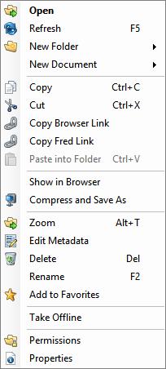

If you do not hold the appropriate rights to execute one of these commands, the command will be disabled.

## Refresh

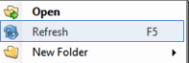

When opening a folder for the first time (or after a certain time span), Fred will query the Alfresco repository and present the contents of the folder. When another user is concurrently adding or editing content in the same folder, updates are only presented in your Fred window when you force (by using the F5 key or through the menu) a refresh of the folder content or, after a certain time span, when the folder is reopened. This will: update the subfolder list, the list of files and its meta-data in the details pane.

## Create folders (New)

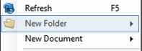

* To create a new subfolder, click “New Folder”.

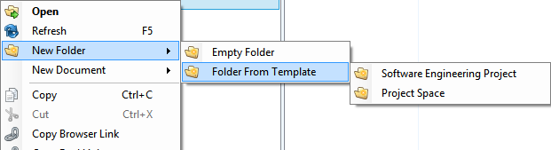

* Select the Empty Folder.
* Enter the name of the new folder and press the Enter key.

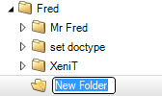

* Or select one of the Template folder structures and input the name of the top folder.

When using a folder template to create a new folder, you will automatically copy all smart behavior functionality (such as rules, scripts, etc) configured in the folder template. Contact your system administrator for more information or if you require assistance to amend the smart behavior functionality.

The ability to create a new folder is not available for any Share Sites folders, as this is a part of the repository that needs to be set-up through the Alfresco Share interface. You can, however, create content in the Share Site document library, as it is a normal folder.

## Rename folders

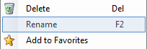

* To rename a new subfolder, click “Rename”.
* Enter the new name of the folder and press the Enter key.

## Metadata of folders

See 15 Handling metadata.

## Move folders

By simply using the drag and drop function, you can move one or more folders to any location in the tree. You can move folders within the Navigation pane or you can move folders from the Detailed pane to the Navigation pane. You will be prompted to confirm you want to move the folders.

Note that you need the appropriate rights to execute a move. You will need, at a minimum, folder creation rights in the receiving folder **and** folder deletion rights in the original parent folder.

## Delete folder

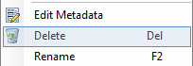

* To delete a folder, click Delete .

You will be able to restore the folder by clicking on the Window/Recycle Bin option. See Recycle bin.

## Copy folder link

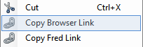

You can copy a link, containing a folder address, to an email or a document. Provided the receiving party has access rights, clicking the link will open the Alfresco browser and display the folder and its content.

## Copy Fred Link

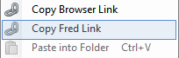

This copies a link that will open up a new tab in the Fred application, with the folder highlighted in the Detail pane.

[Mailbox](https://labnew.xenit.eu/alfresco/service/xenit/link/link-url?context=browse&mode=id&parameter=workspace://SpacesStore/e6f08d3e-9e39-4130-b54e-378ea7718ad2)

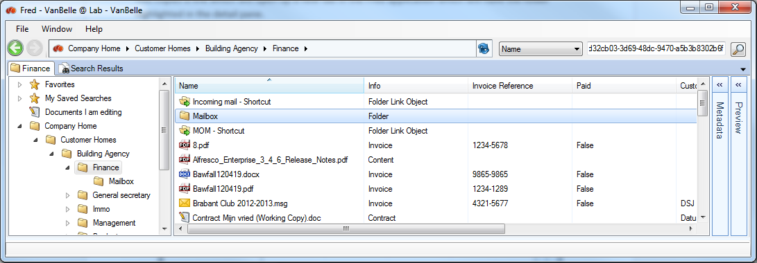

You can put the Fred link as a hyperlink into a document or an e-mail by selecting the option, and pasting the Fred link.

## Create a New document

“New Document” will allow you to create a new document in Fred from templates previously defined on the Alfresco server.

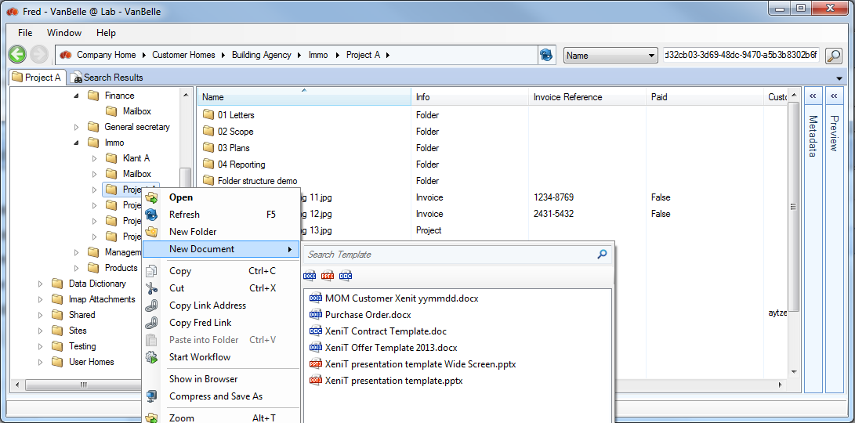

An Administrator, or a user with the appropriate rights, can add a new template documents to a server. Once a template document is added to the folder Company Home/Data Dictionary/Document templates, it becomes available to all users.

You can set document type and metadata values for templates. The documents created from a template will automatically inherit the template’s document type and metadata.

## Show Folder in Alfresco browser

The Show in Browser command enables you to jump from Fred to Alfresco Share interface.

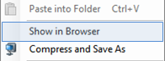

This enables you to view more folder details and use all Alfresco functionality available through the Share interface.

## Print documents

You can select one or multiple documents and print them using the default printer configured on your local PC.

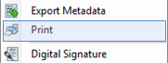

## Paste into folder

When you copy a file from your desktop, this command will be enabled. You will be able to paste the file (using either CTRL V or Paste into Folder) into the selected folder.

To clone a document from Fred, whether into the same location or another folder in Fred, you need to:

* Select the file and click Copy in the file menu (see Copy Document)
* Select the folder in which you want to paste the link to the document
* Click “Paste into Folder” in the Folder menu

Cloning the document into the same folder will create a *‘document_name –Copy.docx’*. Cloning it into another folder creates a *‘document_name.docx’*.

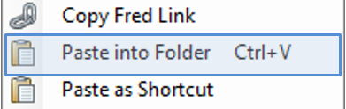

## Paste as shortcut

To paste a link to a document into another folder you need to:

* Select the file and click Copy in the file menu (see Copy Document)
* Select the folder in which you want to paste the link to the document
* Click “Paste as Shortcut” in the Folder menu

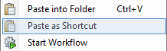

Note that in the Info Column, the file is indicated as ‘File Link Object’. If you want to see the details of the document, double clicking the file will make it jump to the folder in which the document is located and show the metadata details.

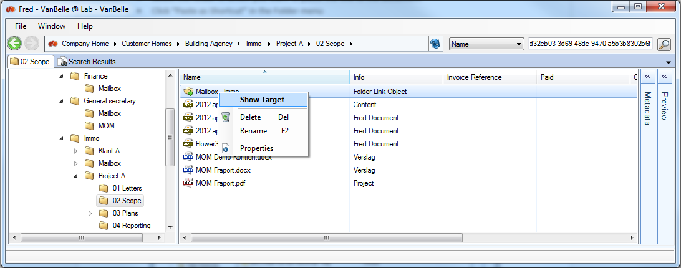

## Folder permissions

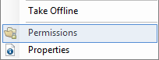

This function is only available for those folders where the user has access entitlements beyond consumer rights.

By clicking “Permissions” on the folder menu, a new tab will open and display the users and group rights set for this folder. The table indicates: which rights are set for which users, if the user received the right through that group, and/or if the rights were inherited from a parent folder, and the Authority Type.

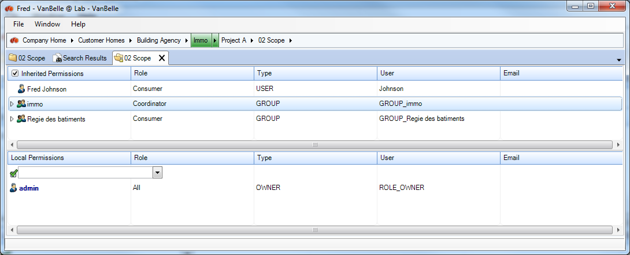

The upper part of the screen shows the permissions that are inherited from the parent folders up to the company home folder.

The lower part of the screen shows the permissions that are set on the selected folder.

Permissions are set for users or groups. Selecting a user or group will highlight (in green) in the breadcrumb the folder in which the permissions are set.

You can click on the folders in the path to see how the rights are set in the folders above.

You can set permissions for users or groups in the Local Permissions section. Click into the cell if you want to add a user. Type a name, and the list of the matching users or groups is displayed.

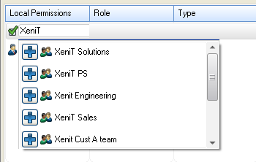

Click on  to add a user or group. That name is now listed in the local permissions table and you can define the role.

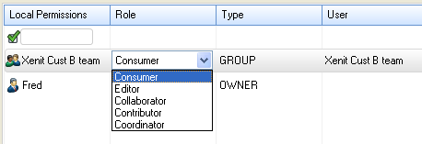

If you don’t want a user or group to have access to the folder anymore, right click on the user’s or group’s name and select “remove permission”.

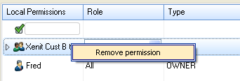

## Multi folder functionality

You can select multiple folders in the Detail pane. Some commands in the folder menu are unavailable when you select multiple folders.

# Taking content offline

You can take part of your repository offline. In the offline mode, you are able to navigate through your offline structure, view the related metadata, and open the documents you have selected to take offline.

## Selecting the content you want to take offline

There are two ways you can take folders offline:

* Via the Favorite Folders menu



* Via the folders menu: when you take a folder in the repository offline, it is automatically added to your Favorites after the synchronization has been completed

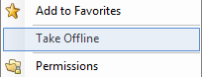

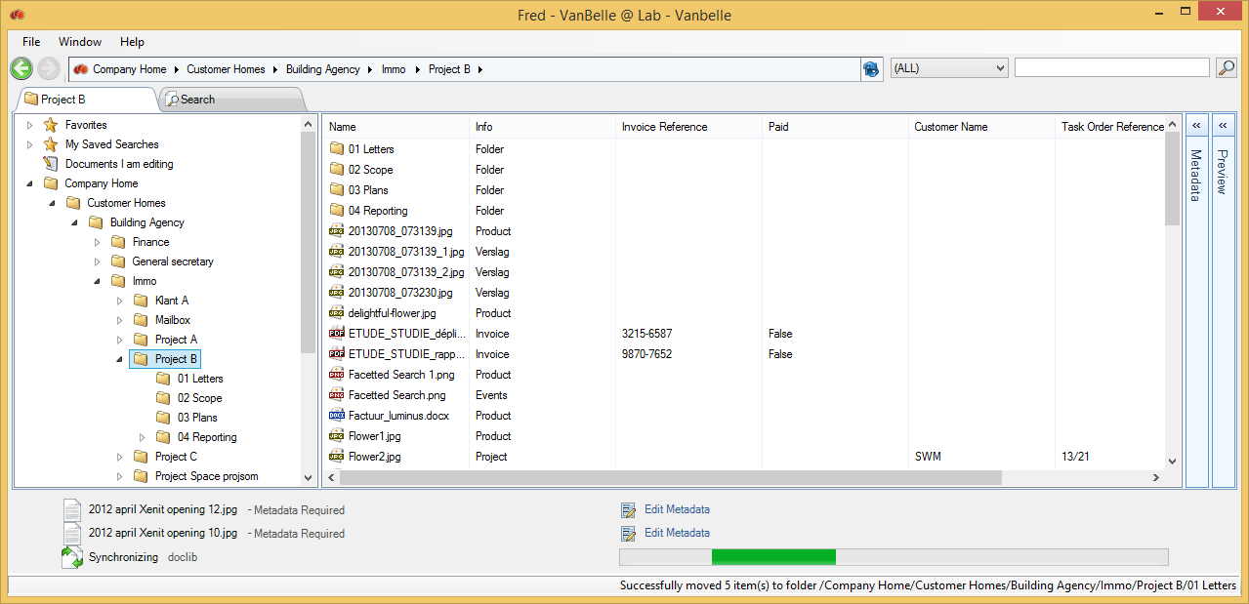

While the folders are synchronizing, a message at the button will alert you that the process is running.

When completed, the folder is visible under the Favorite Folder and is marked with a .

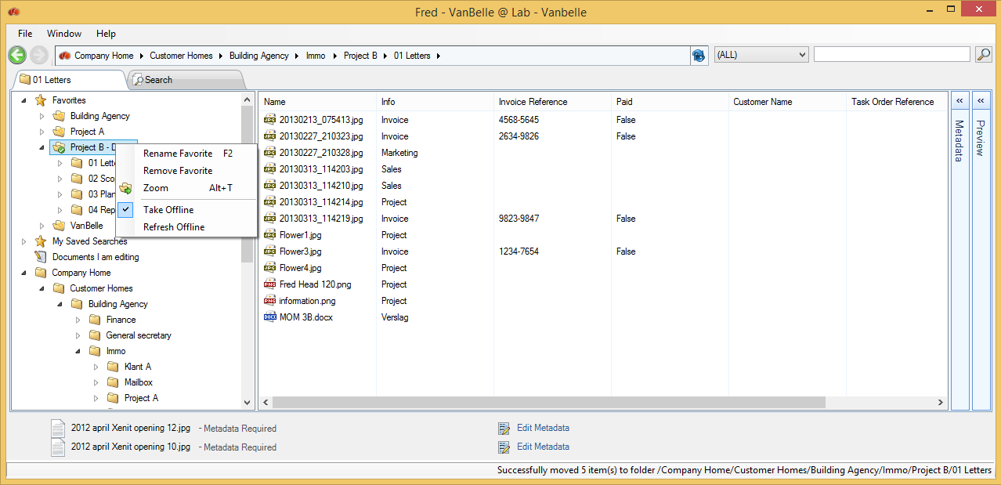

## Refreshing offline coNtent

When you are online, you can refresh the offline content with the newest content available on the server. Fred runs a validation check, and only updates the content that has been changed on the server since the previous synchronization.

## Deactivating Offline sync

If you want to deactivate the offline sync mode, you need to uncheck the ‘Take Offline’ command in the Favorite folder.

## Working in Offline mode

When you are offline, you can connect to the local repository via the Bookmarks menu. First, make sure to disconnect from the network by clicking the File/Disconnect menu. In the list of repositories, right click the bookmark you want to connect to, and select Connect Offline.

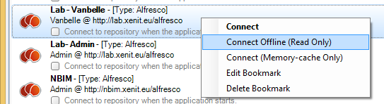

When you are connected, you will be able to navigate in the substructure that has been synchronized.  
Only some of the menu commands will be available whilst you are offline.

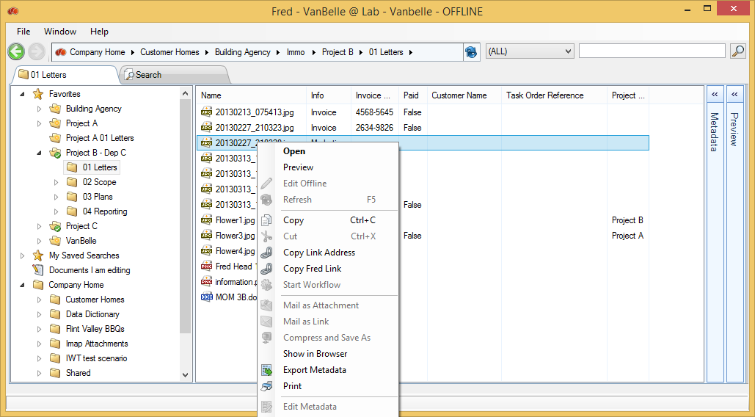

You will be able to:

* Open the documents
* Copy a document and paste it to your desktop
* Copy a link to the document and paste the link in another document or in an email
* Export the metadata which was synchronized
* Print the document to your default printer
* Zoom into a folder
* Add a folder to Favorites

# Adding content to and getting content from the server

## Uploading fileS

You can very easily add any kind of file to the Alfresco repository, by dragging and dropping the file from the desktop application into any folder within the Fred window.

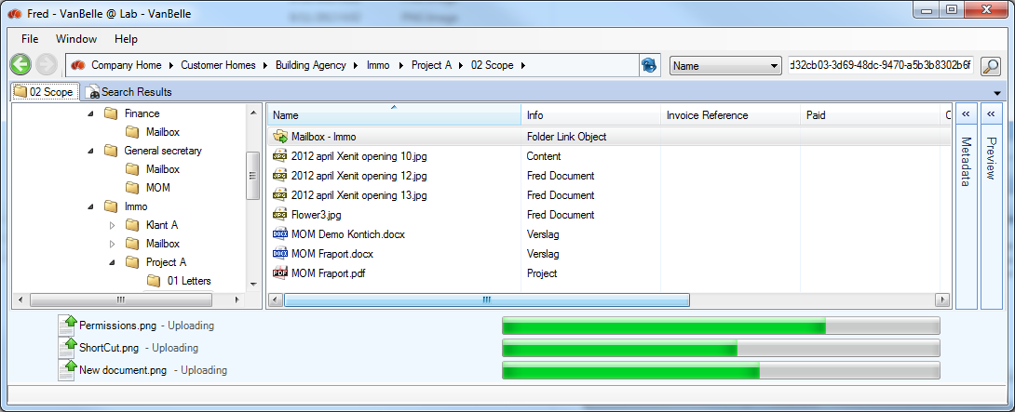

The file will be uploaded into Alfresco. You can drag and drop multiple files simultaneously, or drag and drop multiple single files. While the documents are uploading, you can continue to navigate and work in Fred.

Uploaded documents are listed in the upload pane. Once uploaded, you will need to complete the metadata of the file. Where the document is of a general nature, you can use the base document type selected by default.

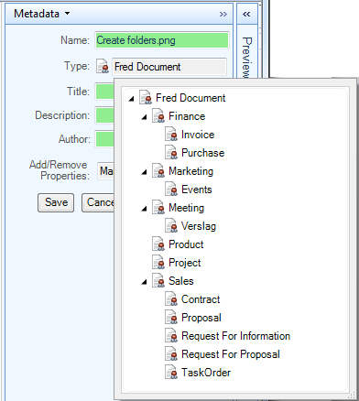

Based upon the document type selected, a set of metadata fields will appear. According to the rules defined by your organization, some fields might be mandatory and others might be optional. In the example below, the document type is a Proposal and the required fields (*) are Proposal Reference and Proposal Status.

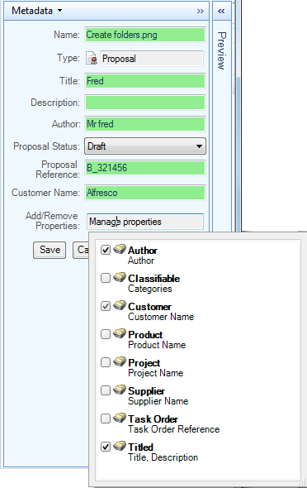

At the bottom of the metadata field related to a document type, a list with optional groups of metadata fields is listed. The user will decide if these optional metadata fields are relevant to the document, and if any of them should be added to the document.

* Click “Save” to finish the uploading of the file into the Alfresco repository.

Note:

* Mandatory metadata fields are indicated by a “*”
* Metadata fields with format restrictions are coloured red when the input does not comply with the restrictions
* You will not be able to save the document if the metadata fields with restrictions are not filled in correctly

The following applications allow drag and drop of content into Fred, and are tested and supported by XeniT:

* Desktop
* MS Explorer
* MS Outlook 2003, 2007, 2010

Other applications might also support the dragging and dropping of content, and could interact with Fred. By checking if the application allows dragging and dropping of a file (including content) into MS Explorer or onto your desktop, you can test possible compatibility. If the initial test is successful, attempt dragging and dropping into Fred.

## Uploading folders

You can upload folders from your desktop or Explorer by dragging them into Fred. An upload process will start, which indicates the number of subfolders and files that need to be/have been uploaded. During this process, the user does not receive an alert that metadata needs to be edited to complete the upload process.

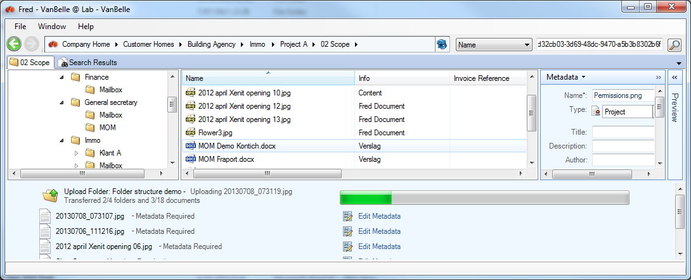

**Important:** you can only extend a folder structure whilst uploading a folder. It is not possible to refresh/update the structure and content from a folder you have already copied to Fred.

Adding documents (whether individually or collectively) to an existing folder structure is supported, and you are able to extend the folder structure whilst dragging a new subfolder structure into Fred.

## Compress documents and folders to a container on your local drive

You can select one or multiple documents and/or folders and compress then into a container, which will be saved to your local drive.

* Select the files you want to compress
* Right mouse click and select “Compress and Save as”

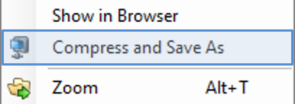

* A browser window will pop-up, asking you to select the folder and name under which you want to save the container

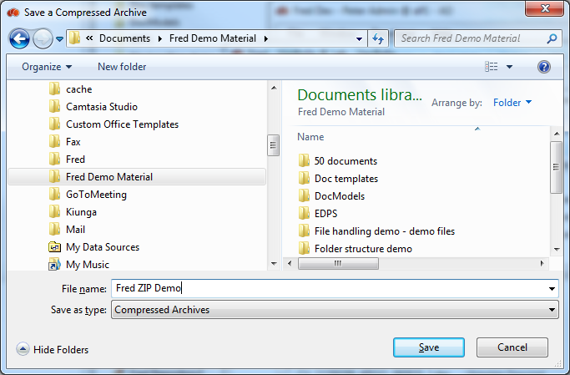

* Fred will provide a message “Successfully Saved Compressed Files”
* The container with the compressed files will be available in the location it has been saved to

Selecting a folder will compress all contents of the folder; that is, including the sub-folders and their content.

# Handling Documents

A command menu pops up when you right click on a file, enabling you to manage the document.

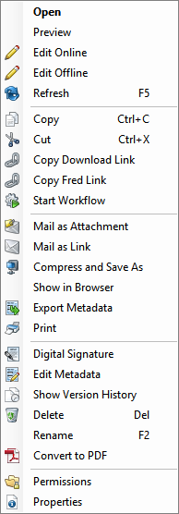

## Open document

Files can be opened directly within Fred by clicking the “Open” command or by double clicking the file. The file will be downloaded to a local copy and opened with the corresponding application.

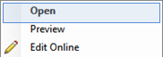

## Document metadata

See Handling metadata.

## Move document

By using the drag and drop feature, you can move files to any location in the tree, if you have the appropriate rights to execute a move. You will need, at a minimum, file creation rights in the receiving folder **and** file deletion rights in the originating parent folder.

## Copy Document

Copying files in Fred will make a copy on the desktop clipboard. You can paste the document to any application on your desktop.

A second way for copying files is to drag and drop from the Fred window onto another application window (e.g., Explorer, Word document, an e-mail).

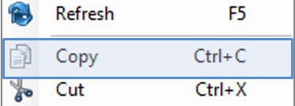

## Copy a file link

Provided that the receiving users have access to the Alfresco repository, it is more appropriate to not copy the file into an e-mail communication, but rather, to copy a link to the document using “Copy Link address”, by right clicking on the file. This avoids the duplication of identical information within the organization.

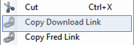

## Copy a Fred Link

This action copies a link which will open up a new tab in the Fred application, with the folder highlighted in the detail pane.

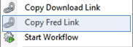

<fred://a1d07cd6-2f5f-4983-99ae-c11f398107dd/browse/id/workspace/SpacesStore/e0348edb-24ff-458a-9f79-1828b4bd1161>



## Mail as attachment

“Mail as attachment” allows you to send a document as attachment by email, directly from Fred.

The document will automatically appear as an attachment in a new email.

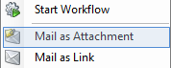 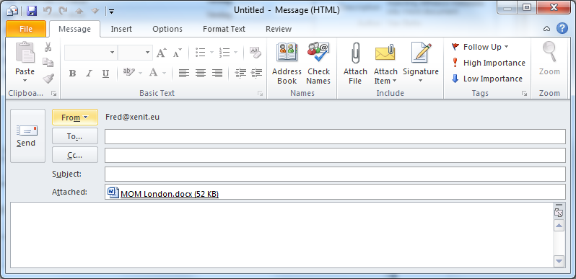

## Send document link via Email

“Mail as Link” allows you to mail a link to a certain file or folder in Fred. Provided the receiving party has access rights, clicking the link will open the Alfresco Browser and show the file/folder and its contents. By using this feature, you will avoid duplication of documents across the organization.

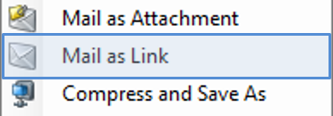 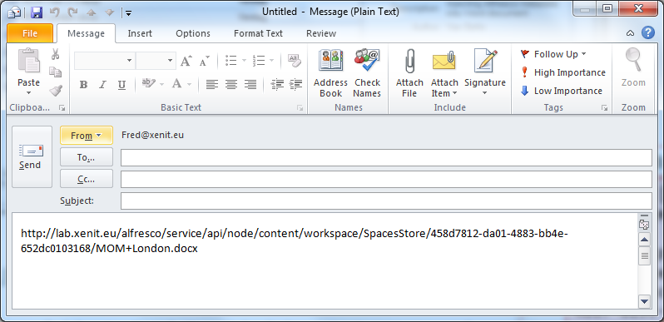

## Rename file

* To rename a file, click “Rename”.
* Or push the F2 key.
* Or click once on the highlighted file.
* Enter the new name of the file and press Enter.

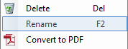

## Delete files

To delete a file click “Delete”. If you do not have the appropriate rights, this command will be disabled.

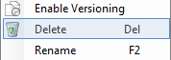

You can delete multiple files by selecting the relevant ones before clicking the “Delete” button.

You are able to restore a file by clicking on ‘Window/Recycle Bin’. See Recycle bin.

## Refresh metadata

The metadata in the columns in the Details pane or in the Metadata pane, are metadata of the specific time you visited this content. If another user has updated the metadata, this will be updated in your view the next time you refresh the folder content (see Refresh) or in the Metadata pane when you reselect the document. You can enforce a refresh of the metadata by clicking “Refresh” or F5 on the folder or the file.

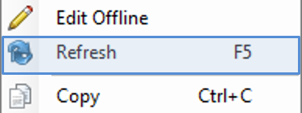

## Locking, Check-out and check-in documents

Locking a document will prevent others uploading new versions of the document, although users will still be able to preview and download the document.

Check-out and check-in are two important functions in a Document Management System (DMS):

* Check-out: you are locking the document for other users and make a “Working Copy” of the document to be edited. Other users will still be able to open the locked document, but they will not be able to modify the document on the Alfresco server. You will be able to modify the “Working Copy” of the document
* Check-in: when you have finished the modifications on the document, you can check-in the document as the “original document”. This will update the original document, remove the “Working Copy”, and unlock the original document. The document is available to for modification by other users.

## Edit offline

The ”Edit Offline” command combines a Check-out and download/opening of the working copy.

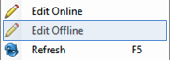

The Edit Offline command in Fred will:

* Lock the document 
* Create a working copy  of the original document
* Download that working copy to your local drive
* Open the working copy for editing

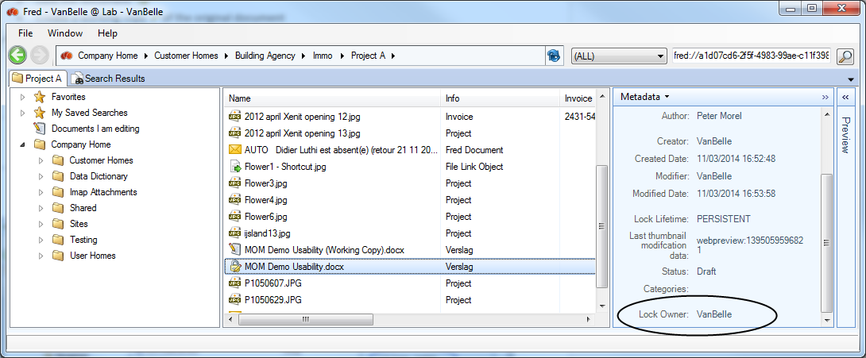

The working copy is copied to a Fred folder on your local hard drive. This folder is defined in the settings (repository tab) of Fred.

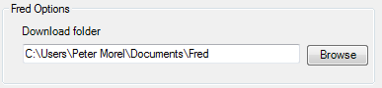

After editing the document, you can save the local working copy of the document without indicating where you are saving the document.

If you want to continue working on the working copy after you have closed the local copy, you can reopen the local copy by double clicking the working copy in Fred or by clicking the “Open” command.

You do not need to drag and drop or upload the working copy to Fred.

With the “Update Main Document” command you will:

* Upload the local working copy to Alfresco
* Update the master (locked) document with the new edited document
* Unlock the master document

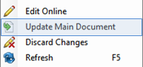

With the “Discard Changes” command, you will be able to unlock the main document and remove the working copy, including any changes you have applied to the document.

## Edit online (NEW)

The “Edit Online” feature lets you edit your document without first saving it offline (checking it out). This functionality is only available for MS Word, MS Excel and MS Powerpoint.

The behavior of the edit online feature varies slightly across the multiple versions of Office and whether you have Single-Sign-One. Below is a description on the behavior when using Office 2013.

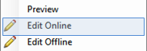

Clicking the Edit Online will open the document.

**Note:** a warning box might appear prompting you to be sure the content can be trusted. Click OK to open the document.

**Note:** if prompted for login credentials, type your user name and password, then click OK. With Single-Sign-On, you can avoid having to enter your user name and password. Contact your system administrator to arrange enabling of the Single-Sign-On feature.

The document opens in a separate window. In the library, refresh the page to see the lock icon associated with the file, confirming other users are unable to edit the document.

**Important:** If the file opens in Read-Only format, contact your system administrator.

As soon as you have clicked the Enable Editing button in Word, or you start editing the document, an invisible check-out action ensures your document remains protected, or locked, in the library during the editing session.

Modify the file as necessary.

Save and close the document.

When you finish editing, the document is invisibly checked in, with the updated version available to other users.

## Pushing metadata from the Alfresco server into Office documents

Fred enables you to write Alfresco metadata values to metadata fields in Office documents (such as MS Office, Open Office). Changing metadata values in Alfresco will change the value in the related metadata field in the document. A prerequisite of this function is that the naming of the metadata field in the document template is the same as in the Alfresco document model.

You can create a document template that uses metadata fields to create the content. Using the above-described mechanism, you can further automate/assist the creation of documents. Some examples of applying this feature are: creation of a corporate document reference number, meeting date, meeting subject.

Contact your system administrator to configure this functionality at the server side.

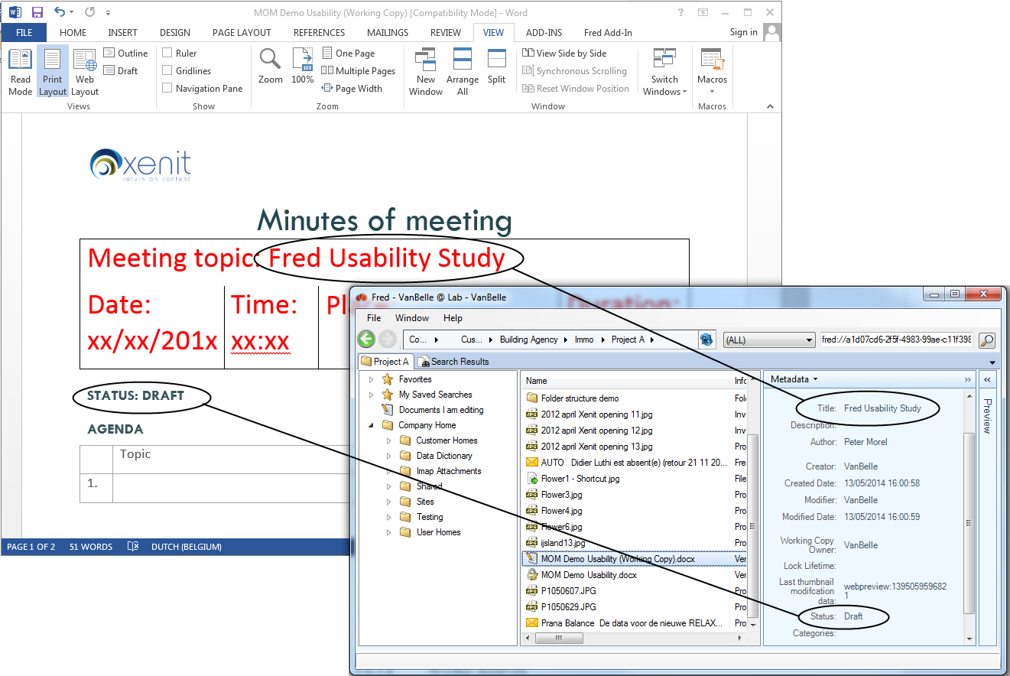

## Word Add-in

It is possible to download and install a Fred Word Add-in. This Add-in shows you all the business metadata that has been pushed from Alfresco into the document.

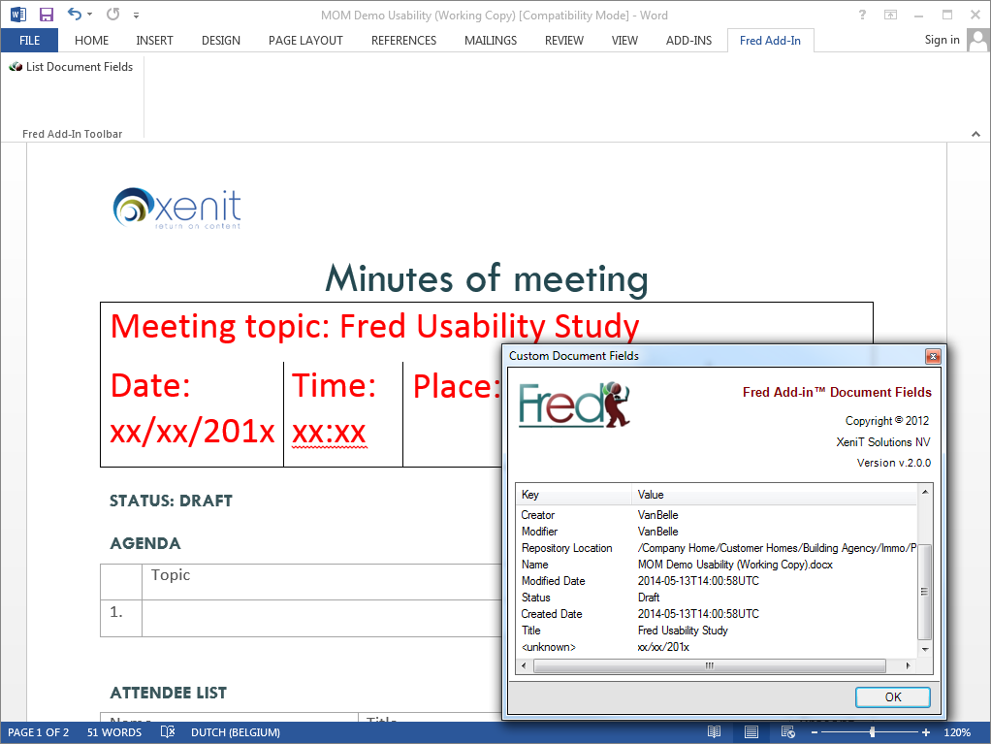

## Convert to PDF

The Convert to PDF command is available for MS Office documents and converts the document into a PDF version using the MS Office application on your desktop.

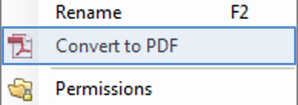

A PDF version of the document is made available on Alfresco in the same folder.

## Preview document (Enhanced)

There are multiple options to preview a document:

* Enhanced preview as provided by Alfresco Share
* Image preview of the first page
* Text preview without formatting. The text is selectable
* Html preview for Outlook email files

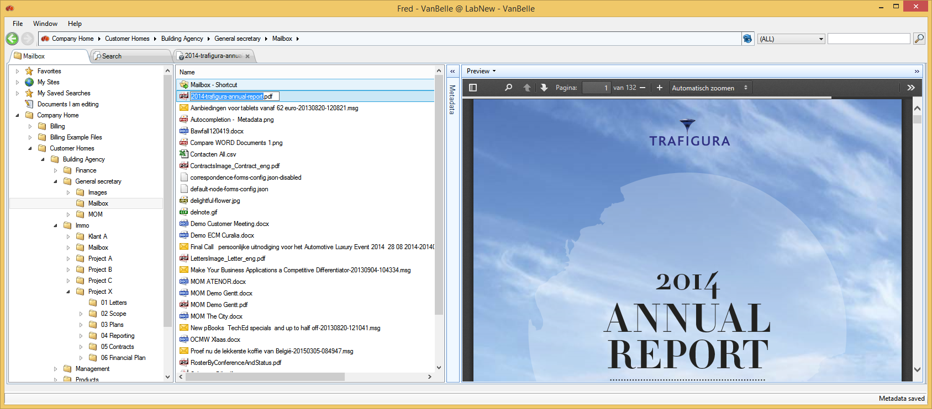

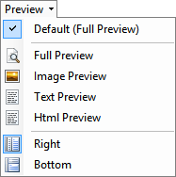

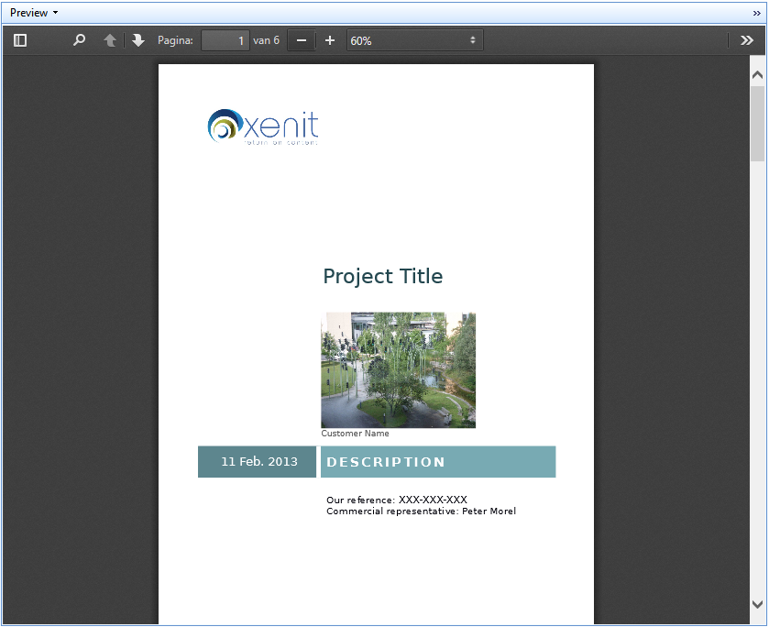 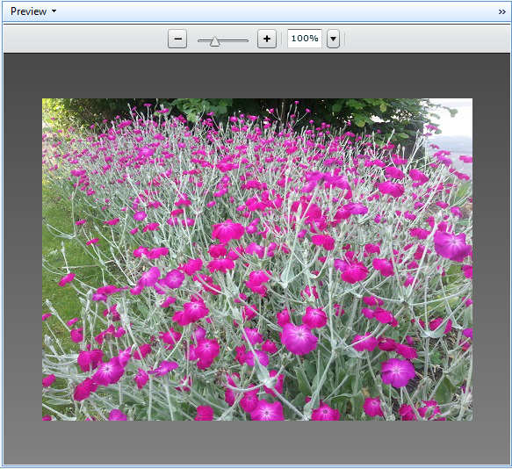

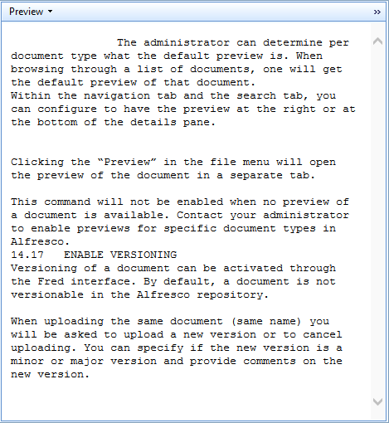 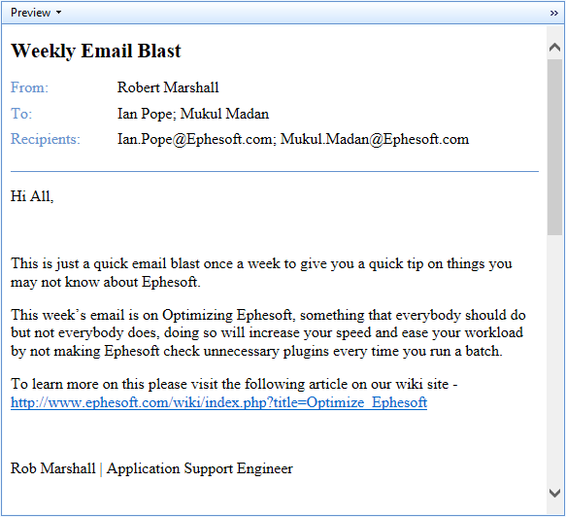

The system administrator can determine, per document type, what the default preview is. When browsing through a list of documents, you will have a default preview of that document displayed.

The enhanced preview feature provided by Alfresco enables you to: search text within the preview of MS Office and pdf documents, select and copy text, and enjoy other useful features.

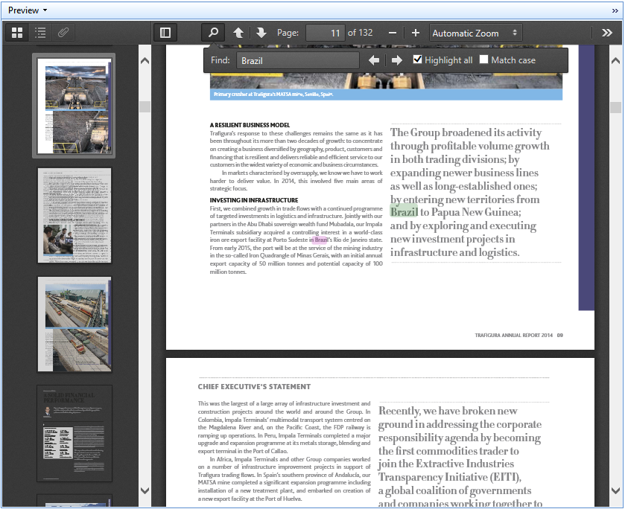

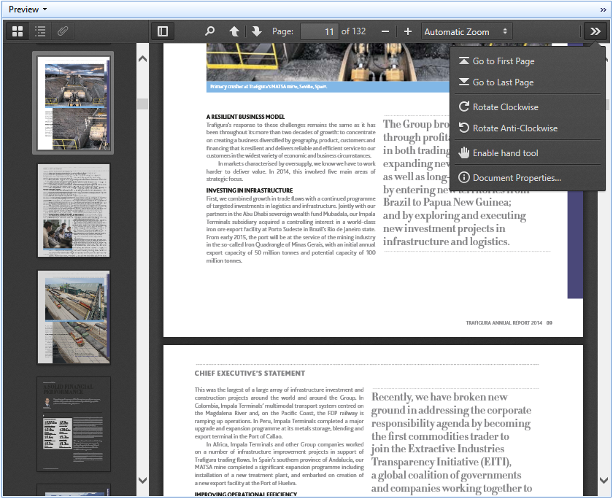

Within the navigation tab and the search tab, you can configure the preview to display at the right or at the bottom of the Details pane.

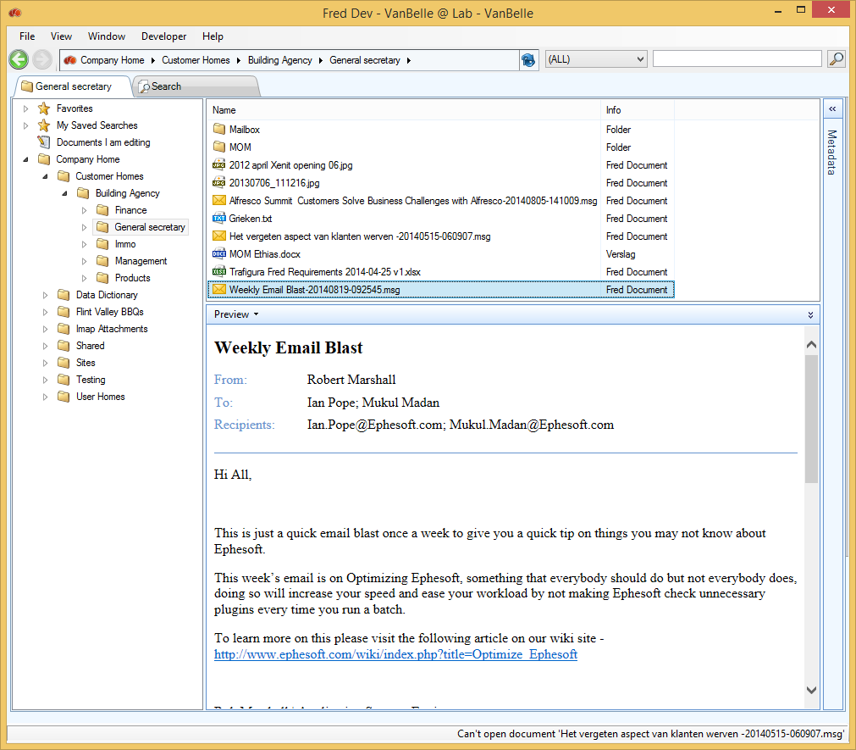

Clicking “Preview” in the file menu will open the preview of the document in a separate tab.

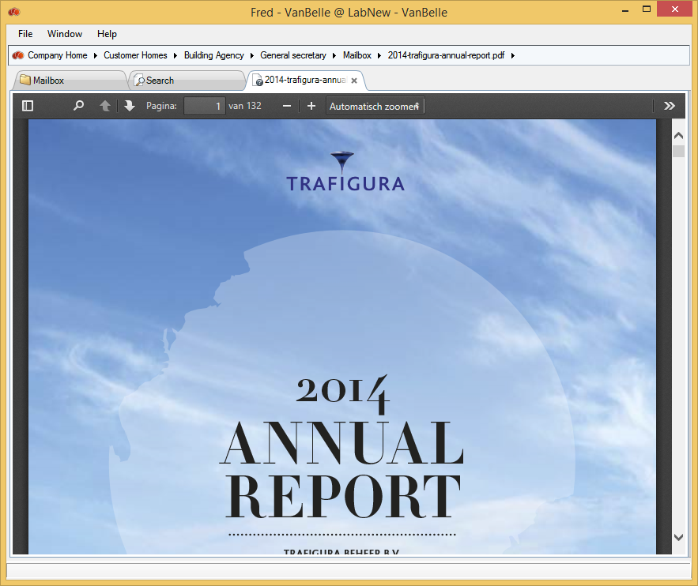

This command will not be enabled when no preview of a document is available. Contact your system administrator to enable previews for specific document types in Alfresco.

## Enable versioning

Versioning of a document can be activated through the Fred interface. By default, a document is not versionable in the Alfresco repository.

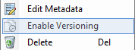

When uploading the same document (same name) you will be asked to upload a new version or to cancel uploading. You can specify if the new version is a minor or major version, and provide comments about the new version.

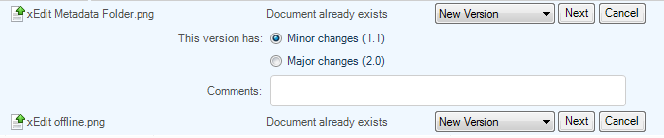

## Show version history

Once a document is made “versionable”, the command “Show Version History” becomes available.

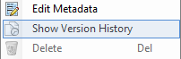

With this command, a list of all versions of the document will be displayed. Every version can be opened individually. You cannot upload documents to this list.

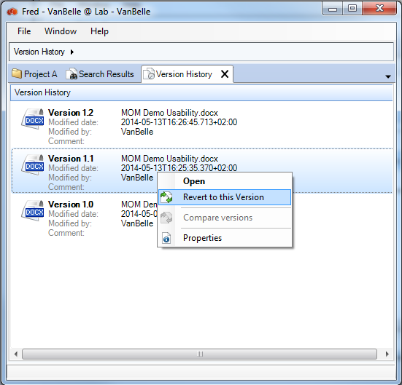

You can revert an older version of the document to the most recent version. This will create a new version.

## Compare WORD documents

You can compare two version of a Word document. When selecting two versions of a specific Word document, the “Compare Versions” command will be enabled.

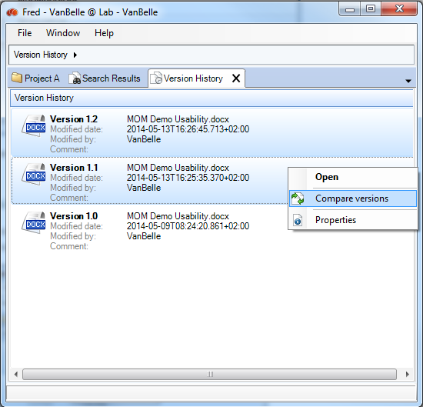

The “Compare Versions” command will download both versions, and use the Word application on your desktop to compare the two versions.

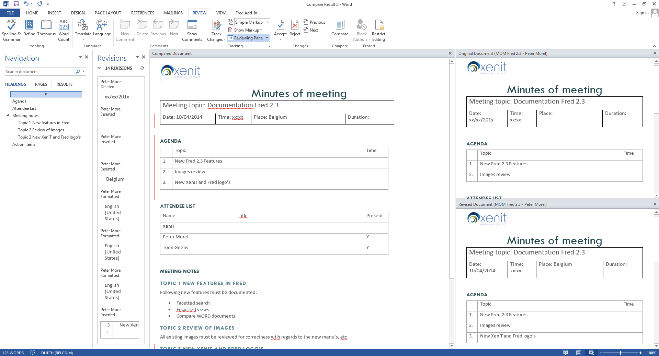

## Show File in Alfresco browser

The “Show in Browser” command enables you to jump from the Fred window to the Alfresco Web Interface. This allows you to view more file details, and use all functionalities available in Alfresco.

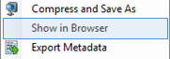

## File permissions

Similar to Folder permissions, you can read and set permissions on files.

See ‘Folder permissions’ for more information.

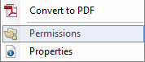

## Multi document functionality

Some commands in the File menu are available when you select multiple folders.

## Using shortcuts

A full list of the shortcuts available:

* Ctrl+C= Copy file/folder
* Ctrl+X= Cut file/folder
* Ctrl+V= Paste file/folder
* Ctrl+A= Select All
* Ctrl+Q= Quit application
* Ctrl+F= Quick search in Fred
* Ctrl+T= Add new tab
* Ctrl+A= Select all objects in the Detail navigation pane or in the Details search pane
* Del= Delete file/folder
* F2= Rename file/folder
* Backspace= Previous menu
* Alt+arrow left= Go to previous menu or submenu
* Alt+arrow right= Go to next menu or submenu

# Handling metadata

## Viewing METADATA of folders

You can view the metadata linked to a folder in the Metadata pane. The metadata appears when you select a folder in the Navigation pane or in the Details pane.

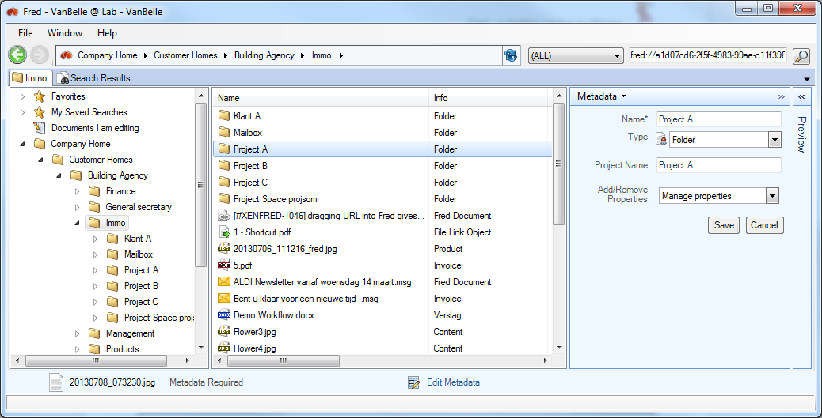

## EDIT METADATA of folders

* To edit the metadata fields of a folder, click “Edit Metadata” in the Metadata pane.

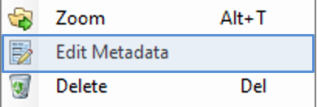 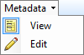

## Viewing Document metadata

Metadata of files and folders are presented in the Metadata pane. As you scroll through the list, data in the Metadata pane will be updated.

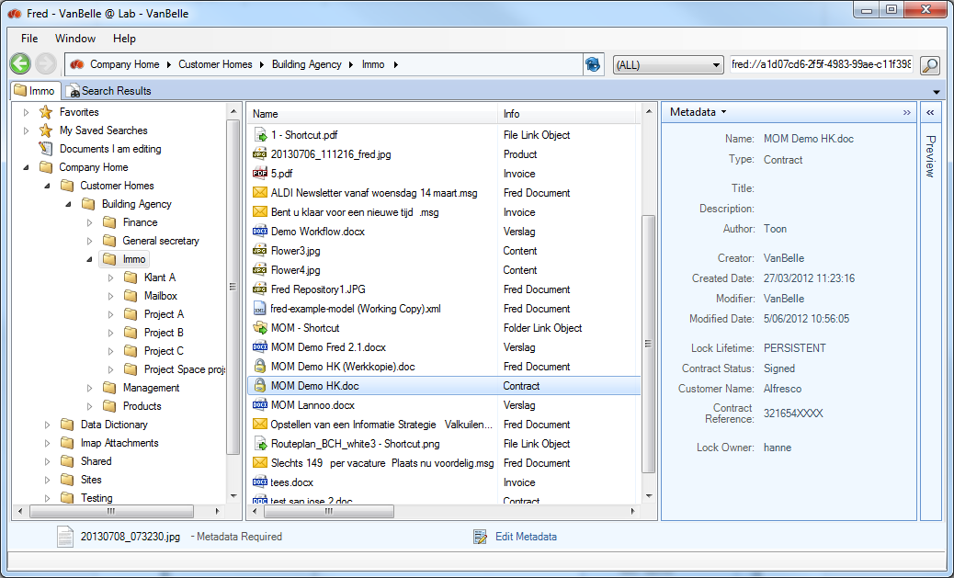

In the example above, you will see that this document type is a “Project”, which has the standard metadata field (creation date, creator, etc) and some specific metadata fields (project name, customer name, etc).

## Edit Document metadata

“Edit Metadata” will open a window to edit the metadata field values. You can perform edits such as adding further detail to the document type and/or add additional optional metadata groups. These steps are described in ‘Uploading file’.

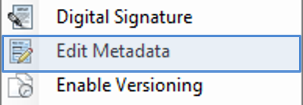 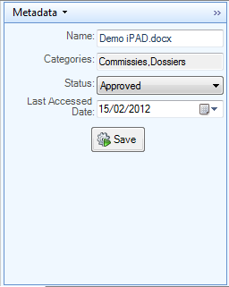

## Auto completion of metadata values (SOLR)

When the Alfresco server is using SOLR indexing, you can activate the text metadata field to enable auto completion behavior. Then, while you are typing, Fred will suggest possible values that fit the text you are typing. As you narrow down the options whilst continuing to type, you can select, with either the mouse or with the keyboard arrows, the correct value and move to the next field.

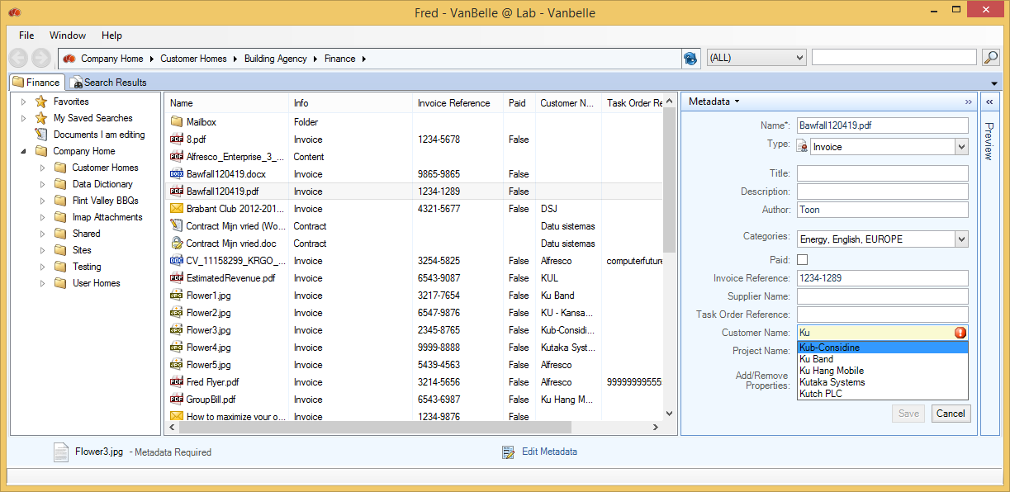

**Important:**

* Auto suggestion is case sensitive!
* When you add a new value to the file, it will take some time before this value will appear in the suggestions. The delay is dependent on multiple elements specific to your environment. In ideal conditions, the delay will only be 15 seconds long.

## Viewing metadata of Multiple documents

All metadata fields, as defined in the Alfresco document model, can be selected as a column in the Fred window. This allows you to sort the files. See ‘Handling views for more information.

## Editing metadata of Multiple documents

Selecting documents in the Details pane will show the metadata fields which are common for the selection in the Metadata pane. Where all fields are blank or have identical values, they will be presented in the view mode. In the view mode of the Metadata pane, fields that have different values in the document selection will be marked as ‘Multiple values’.

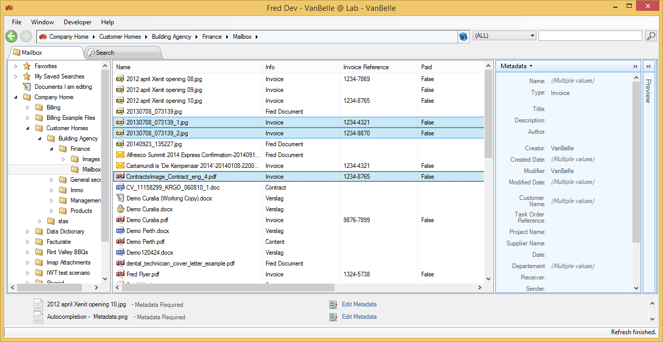

When you select the edit mode of the Metadata pane, you will be able to update the values of the common metadata fields. Please note:

* Not filling in a field will not change the existing values in that field
* Filling in a value in a field will overwrite the existing values in that field

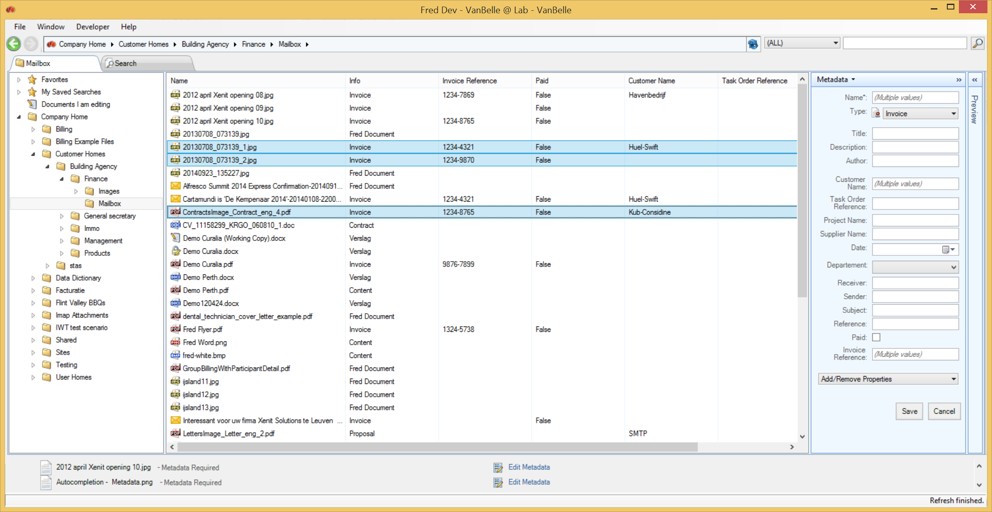

For each column, the following behavior is defined as:

* Checkbox  or  indicates that all documents have that value
* Checkbox  indicates that the selection contains multiple values
* When clicking the checkbox, it will iterate between ,  and . This is indicating that your input will result in a new value  or , for that field, or that you want to leave the different values in the document selection unchanged.

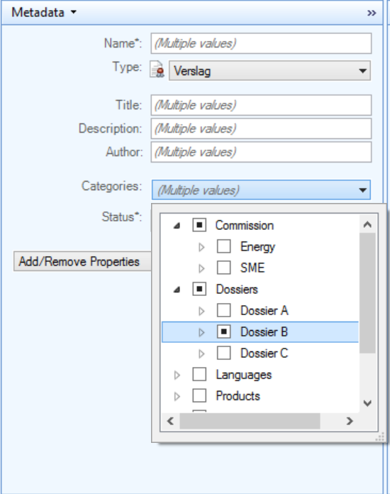

## Exporting metadata

In the Detail pane and the Search pane, you can export the metadata of selected objects and save them to a comma separate file on your local drive.

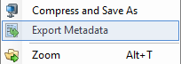 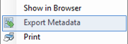

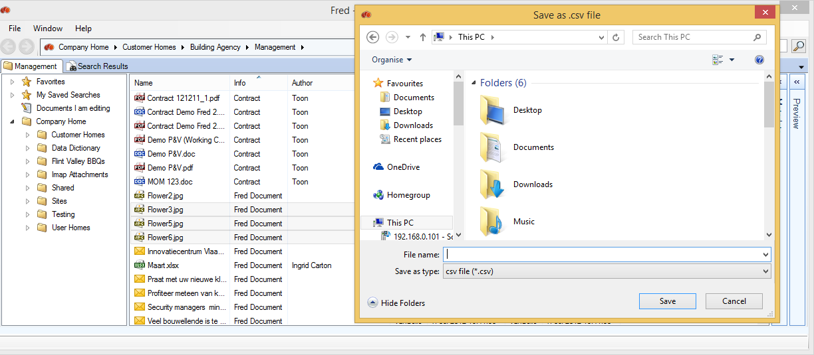

The metadata of the columns that you selected in the view will be exported to a local file.

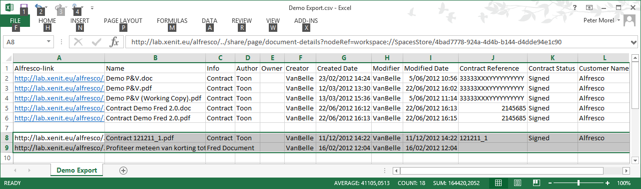

You can now add additional records to the list by selecting new objects and using the shortcut CTRL + C or the COPY command to copy the metadata to the desktop clipboard. You can then paste the metadata values to an excel table.

You can configure a hyperlink to the object, which should be added as the first column. This parameter is set in the Advanced tab of the Fred configuration: File>Open Settings

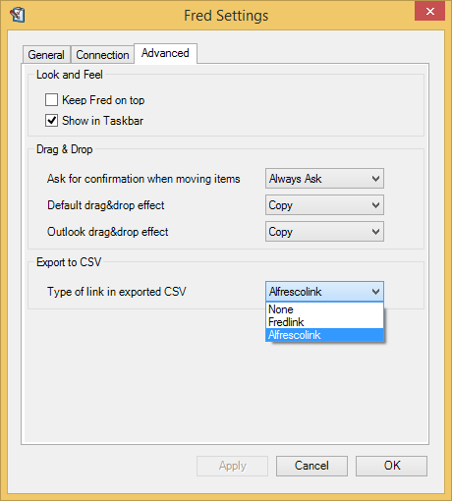

## Metadata governance – Mandatory metadata

When uploading documents to the server, standard document properties are extracted automatically from the document and you are able to edit the business metadata. You can choose to keep the default document type, and not add extra metadata.

Adding extra metadata fields and values is helpful in finding the content at a later date, and providing additional details of the content. To guide the users in completing the appropriate metadata, you are able to add some additional metadata governance in specific folder structures.

This functionality needs to be properly configured on your server. Contact your system administrator for configuration services.

How to activate the metadata governance on a specific folder

You can activate the mandatory metadata governance on a specific folder and its subfolders by adding the Enable Metadata Aspect to the folder.

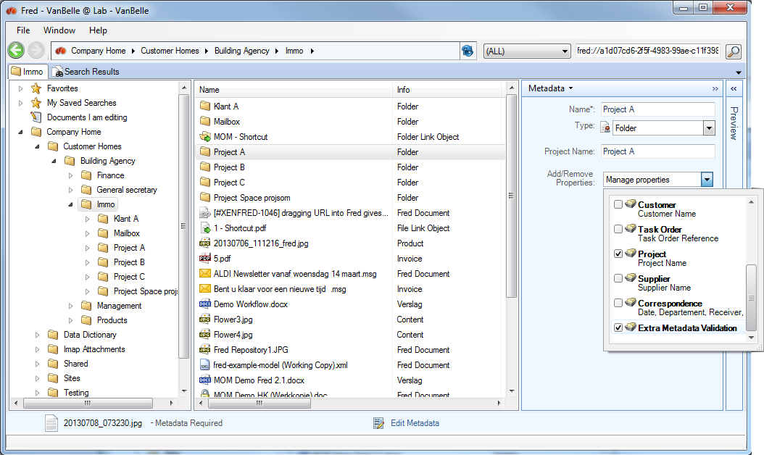

An indication that the Metadata Validation is activated, is provided in the metadata panel of the folder, as shown below.

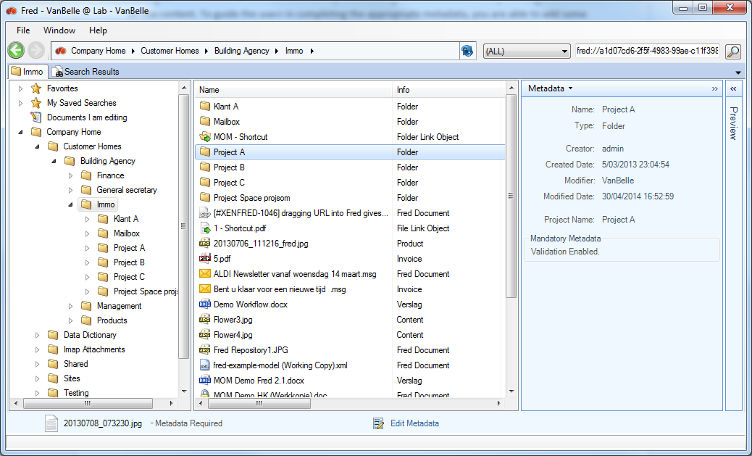

Metadata Validation behavior

When Metadata Validation is activated on a folder, the following behavior will be default:

* You will be able to upload documents into this folder structure
* A document for which the document type or the metadata values are not compatible with the metadata governance rules, will remain visible in the upload progress pane, until the metadata is completed correctly
* If you are uploading too many documents with metadata that do not pass the validation check, you will be restricted from adding additional documents to the repository. The parameter of number of ‘invalid’ documents is set on the server.

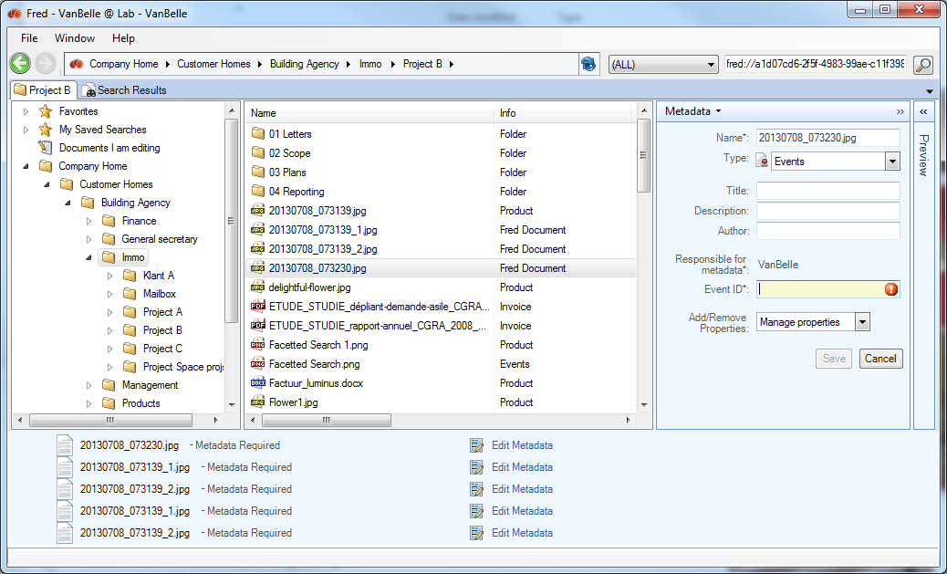

Metadata validation rules

* The document type cannot be generic (e.g. Fred Document, Company Document) and must be specified in detail (e.g. Invoice, Project, Minute Of Meeting). The list of document types which are considered ‘generic’ is defined on the server.
* For document types that contain mandatory metadata fields (indicated by a * next to the description), the fields must be completed with the appropriate values.

Behavior with rules

When documents are uploaded into folders where automated rules are changing the document type and/or the metadata values, the validation check will run against the values after the rule has been executed. If the validation is positive, the document record will be removed from the upload pane after you have save the metadata.

Other people updating the metadata

When other users complete the metadata, the validation check will be positive and the document record will be removed from the upload list.

## Easy integration with third party metadata applications

Fred includes the possibility to connect to a metadata database or table, in which it can query metadata values linked to a record key (i.e. customer ID stored in Alfresco metadata field) in the database and present these values in presentation fields in the Fred User Interface.

For more information, contact your IT team.

# Handling views

## Show columns

In the Browse pane and the Search pane, you can add columns to the view by a right mouse click on one of the existing column headers, and selecting “Show Column”. In that list you can select or deselect the field you want present or hide in the column.

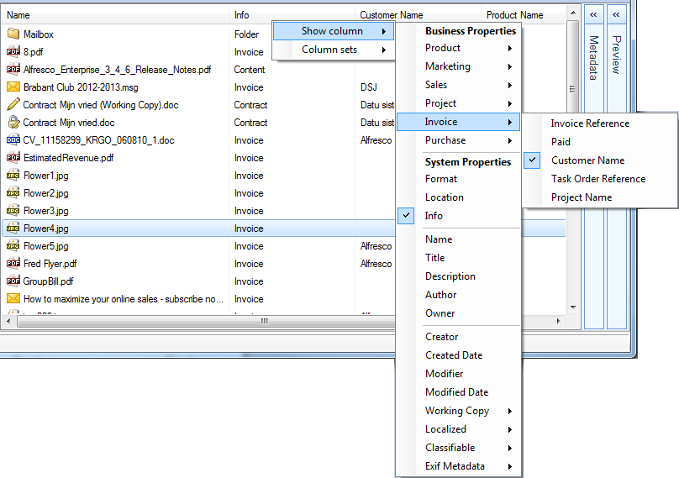

The list of fields is the summary of all metadata fields in all document types defined by your organization. You can modify the width of the column by dragging the edge of the column header. Note that these modifications will be saved as the default view when you open Fred at a later date.

## Show a set of Columns

In the Browse and Search panes, you can change your column view; Fred allows the selection of a predefined or custom defined set of columns.

The predefined column sets are the document types defined in the Alfresco document model. Selecting one of these document types will show all metadata fields related to this document type in the columns.

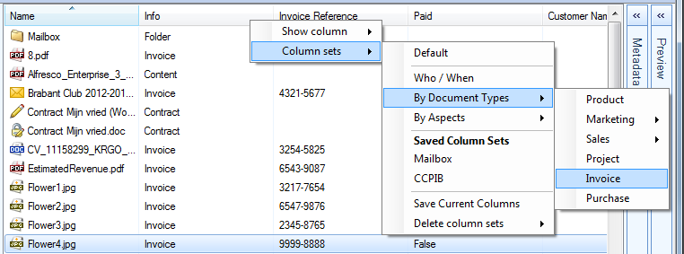

You can select the individual columns you want to add in your custom view. This view will be set as the actual view and will be maintained when closing and reopening the repository.

## Creating personal views

You can select a specific set of columns and save this view with the “Save Current Columns” option. You will be prompted to provide a Column set name. This column set will then be available under “Saved Column Sets”.

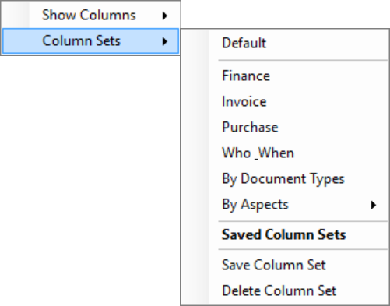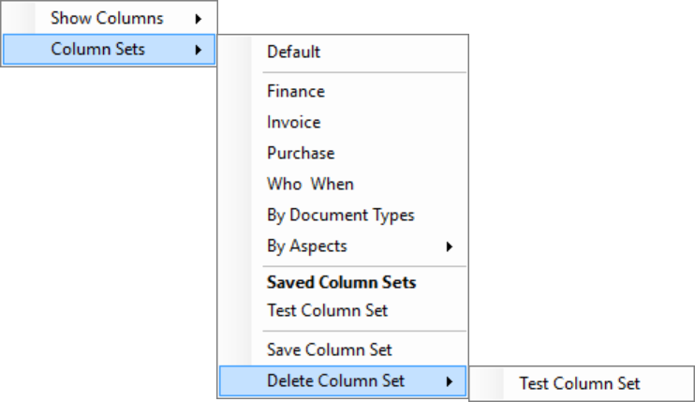

You can remove the custom column set by using the “Delete Column Sets” command.

## Sort on columns

Clicking on the column header will sort the files by alphanumeric values within the folder.

## Zoom

The Zoom function provides alternative and extended navigation functionality in a subpart of the folder structure. It is mainly used to provide a different view of the content in, for example, a project folder.

Initially, Zoom provides an extra navigation structure, based on the Category structure, as defined on your Alfresco server.

Select the folder and click on Zoom.

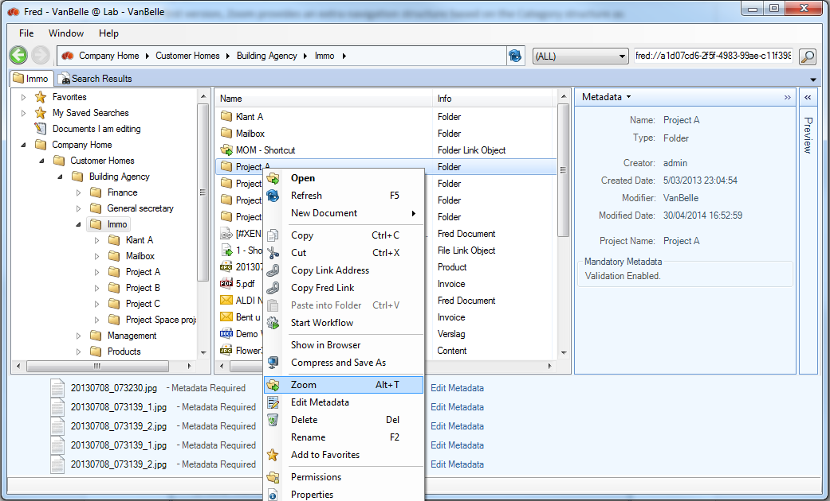

A separate tab will open where the selected folder will become the root folder and the sub folder structure is presented. All navigation and document functionality is available, provided you have the permissions in this sub structure.

The category structure is presented as an additional navigation structure. Selecting a folder will filter the content in the above folder structure and present the list in the Details pane.

In the example below, selecting Commission will present all documents for project A, which have been tagged with the categories ‘Commissies’, ‘Energie’ and ‘KMO’.

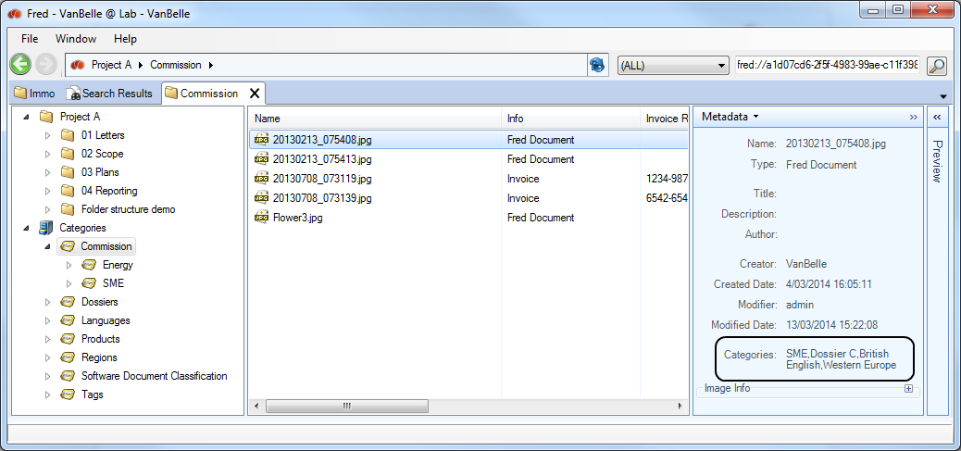

Uploading documents into the Zoom tab

You can upload documents into a specific folder in the Zoom tab.

You cannot upload documents when you are navigating in the Category structure, as this does not indicate the folder in which you wish to upload the document.

## Virtual views

A Virtual folder is a filtered view on a part of the document repository. It allows you to create a virtual folder structure based on filtered views on the repository.

Below is an example of views defined for an invoice approval process. The views are defined in configuration files in the Data dictionary. For each folder, you can define the filter, the folder icon, the columns, etc.

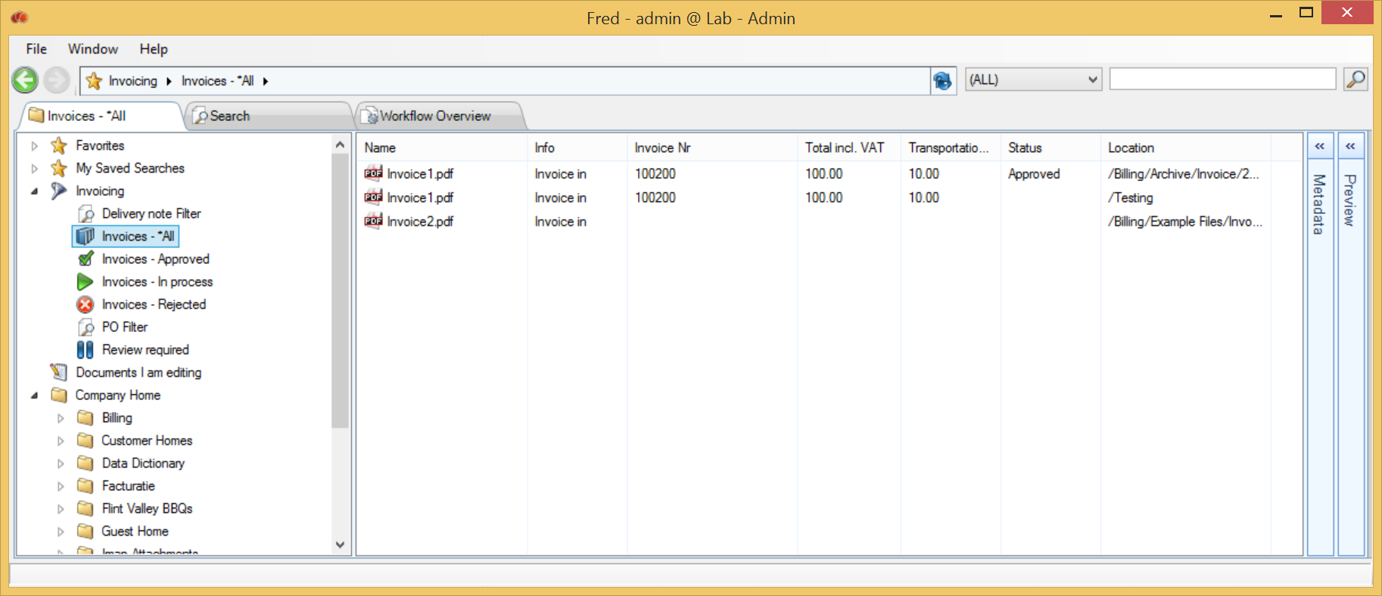

The system administrator can configure Virtual Views.

# Searching

## Simple search

At the top of the Fred Window you are able to type in any text you are looking for.



The search will look for the text in any metadata field and in the text of the document if it is text-searchable. The search will be restricted to the folder set in the breadcrumb and its subfolders.

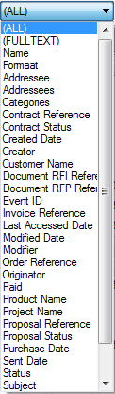

A generic search will look for this value in:

* Folder names
* File names
* Metadata fields
* Document searchable content
* Format

If you select a metadata field, the search will be restricted to this metadata field.

If you select “Full Text”, the search will be restricted to searchable content.

Some simple rules to optimize the search result:

* Blanks between words will provide a search result where both words appear
* Use wildcards before and/or after the word (e.g. *health*) when you are looking for that text in a part of a metadata field, document, etc.

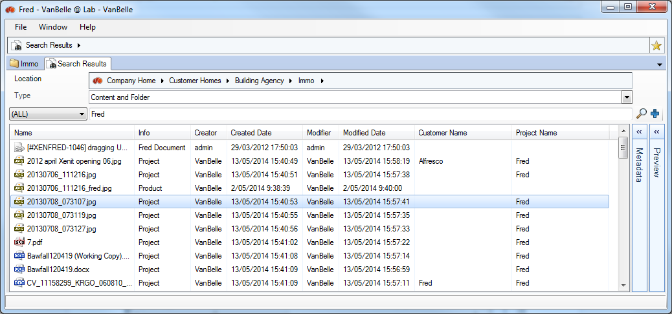

The search result will be presented in a separate tab as a list view, and show all available field values of the selected columns. You can select the column set you want to see, and the list can be sorted by clicking on the column header.

## Dropping an Alfresco Link or Fred link in the Search field

If you have received an Alfresco or Fred link to an object, you will be able to copy and paste it into the Search field. The object will appear in the search result.

## Advanced search

A simple search can be extended to an advanced search. To add or delete search criteria, click on .

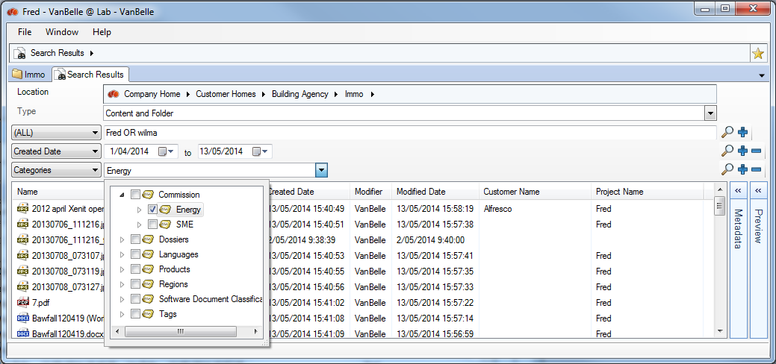

If you wish to refine your search, you can add as many metadata fields as you want. Click on the  to execute the search.

## Facetted search (Enhanced)

Where SOLR indexing has been activated on the Alfresco Server, you will receive additional filtering functionality in the search result. On the left side of the search result, a list of facets and the values present in the found records will be presented.

The facets appearing in the left column are predefined by your organization. Contact your IT team if you require additional fields available in this list to optimize your search.

For each facet defined in the search pane, a list of values that appear in your search result, and the number of records containing that value, are presented.

Selecting one of the values will filter the search results to those documents containing that value. The facets pane will be updated to the new search result. The Facet fields and the number of records will be updated to those appearing in the filtered result.

In the example below, selecting “Modifier” VanBelle filters the search result to all documents modified by VanBelle, and the facet values and the number of hits (Verslag from 21 to 19 hits) will be filtered to this content, where VanBelle is the most recent Modifier.

By selecting multiple facets, you can quickly narrow down the search result and find locate the document you are looking for.

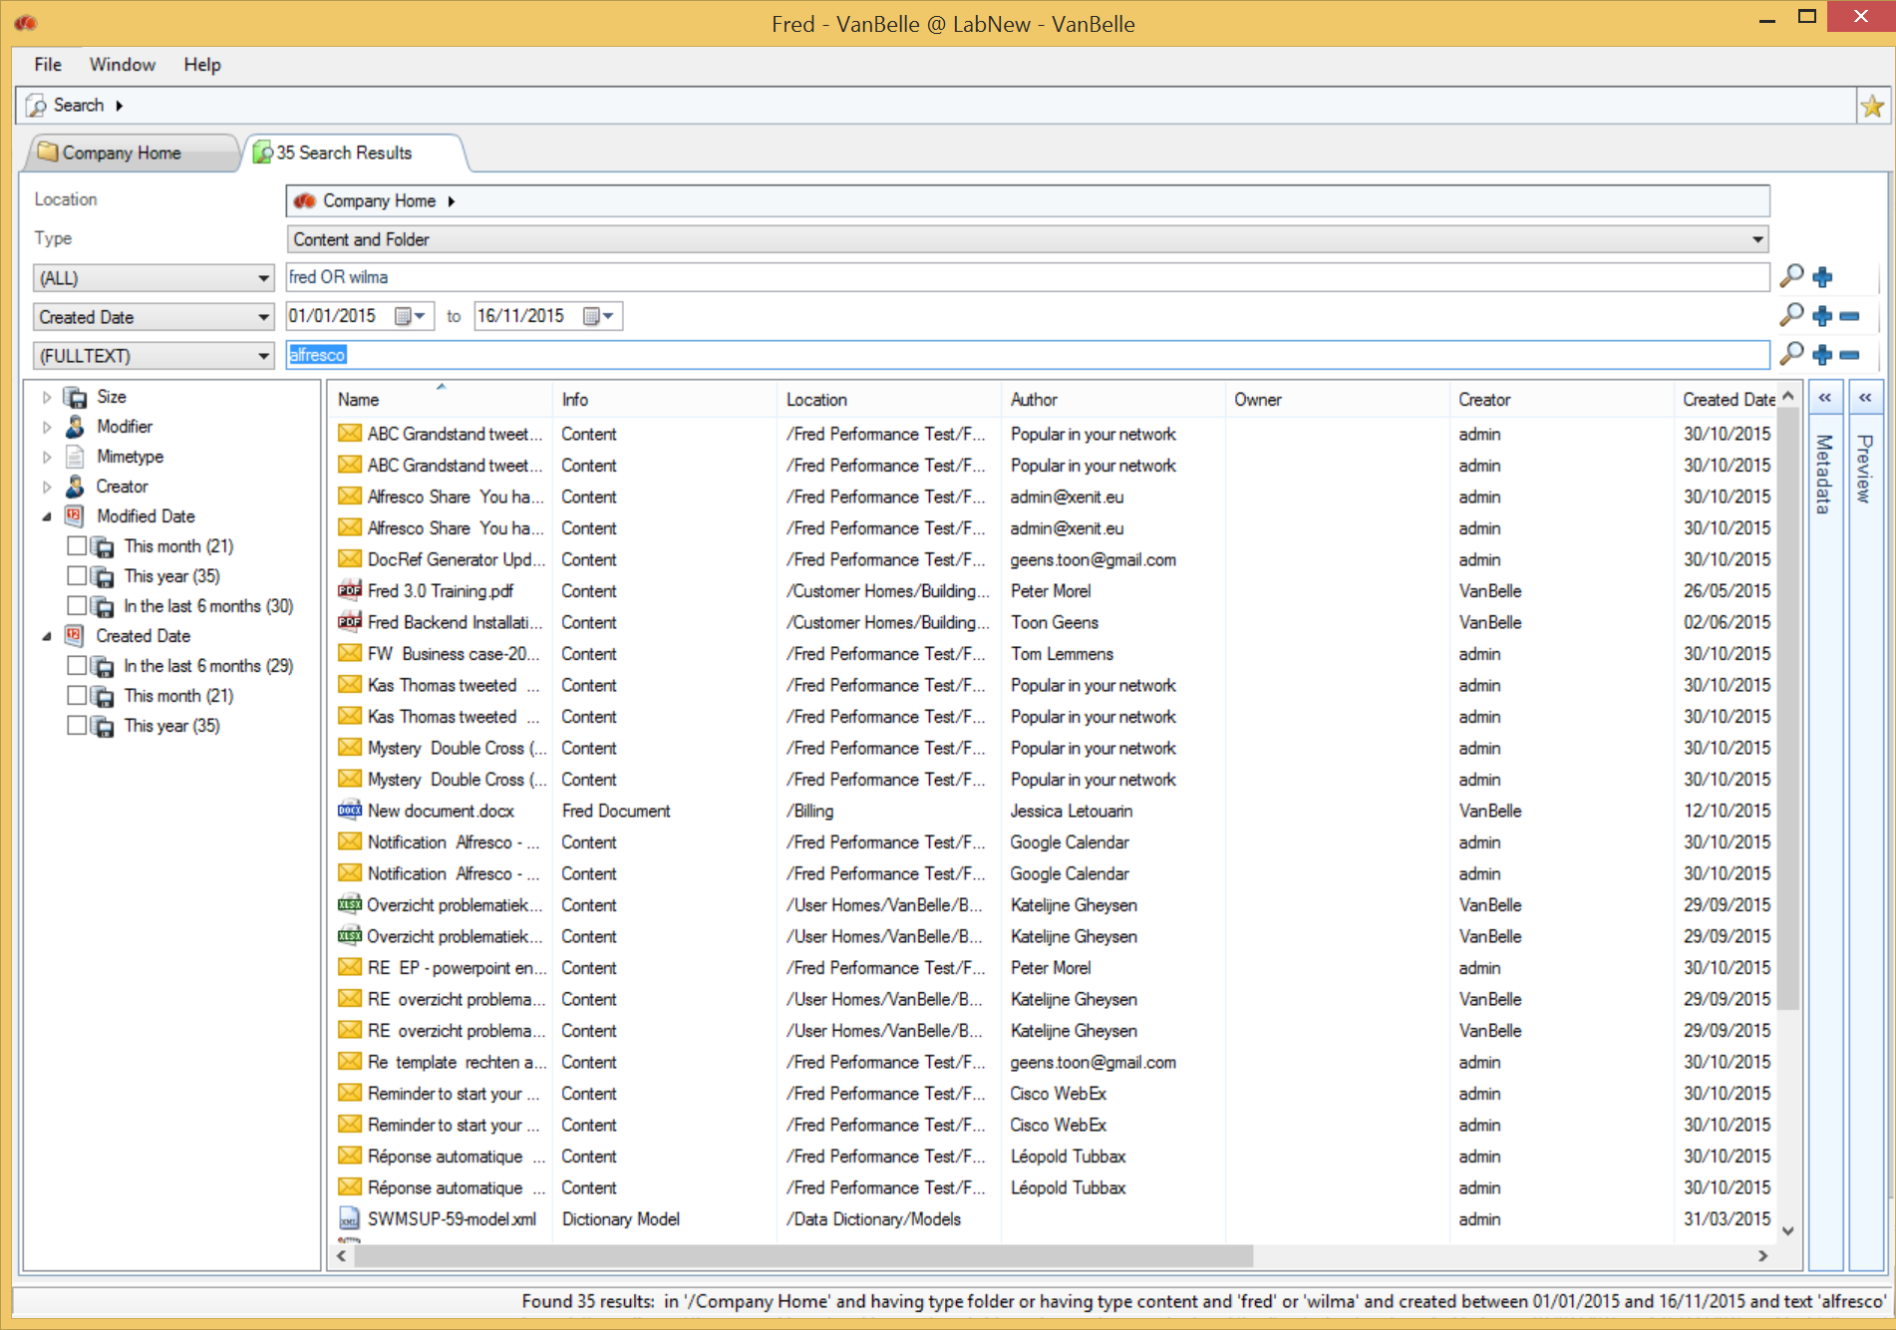

Filtering using facets

From Version 5.0 onwards, Alfresco supports SOLR 4.x. This brings with it a new range of facet features. Facets allow you to filter the search result according the facet value you select.

With Fred 3.3 or higher, combined with Alfresco 5.0 or higher, you will have facet buckets available for dates and volumes.

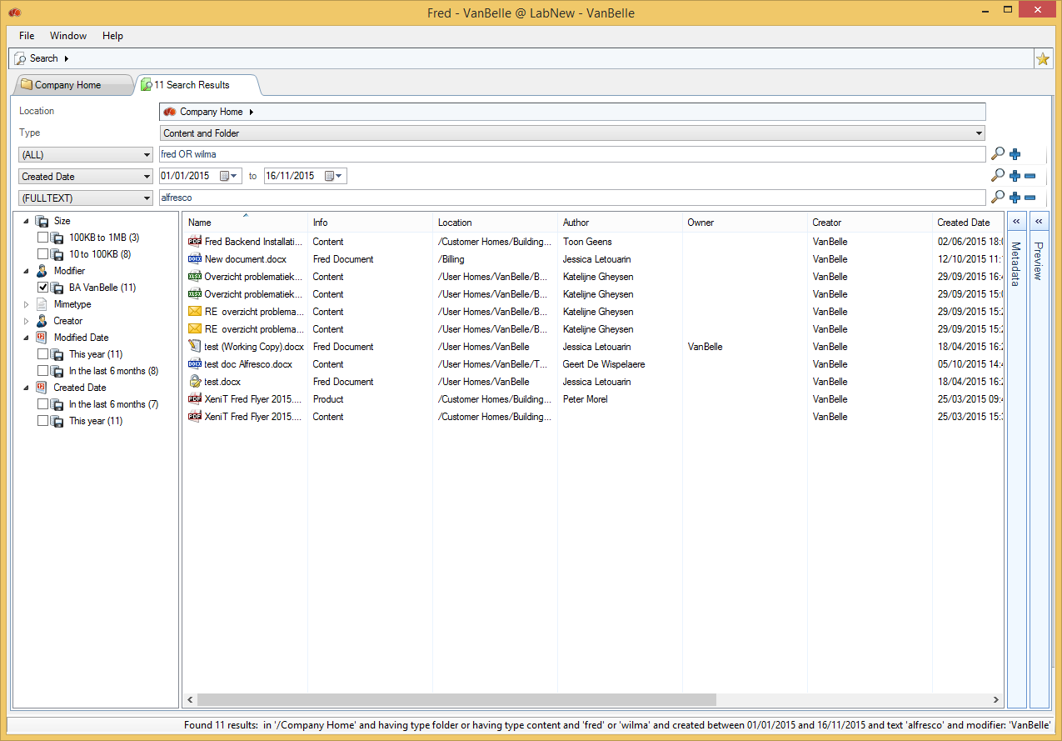

## AND, OR and () operators in text fields

In text fields, you can use OR, AND and () operators to make an advanced search on a specific field.

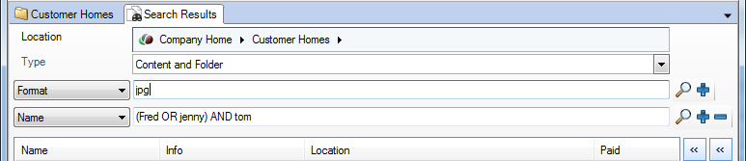

The behavior in this field is as follows:

|  |  |  |
| --- | --- | --- |
| Input user | Presentation after pushing Enter | Search result |
| Tom Jerry | Tom AND Jerry | Tom AND Jerry |
| Tom OR Jerry | Tom OR Jerry | Tom OR Jerry |
| “Tom and Jerry” | “Tom and Jerry” | “Tom and Jerry” |
| Tom Jerry OR Goofy AND “Donald Duck” | Tom AND Jerry OR Goofy AND “Donald Duck” | ((Tom AND Jerry) OR Goofy) AND “Donald Duck”  (Tom AND Jerry) AND “Donald Duck”  Goofy AND “Donald Duck” |
| Tom Jerry OR (Goofy AND “Donald Duck”) | Tom AND Jerry OR (Goofy AND “Donald Duck”) | (Tom AND Jerry) OR (Goofy AND “Donald Duck”)  Tom AND Jerry  Goofy AND “Donald Duck” |

## Messages in search result

The system administrator can limit the search results on the Alfresco server. Where limits are triggered during the specific search action launched by the user, Fred will display a message that additional search results might be available.

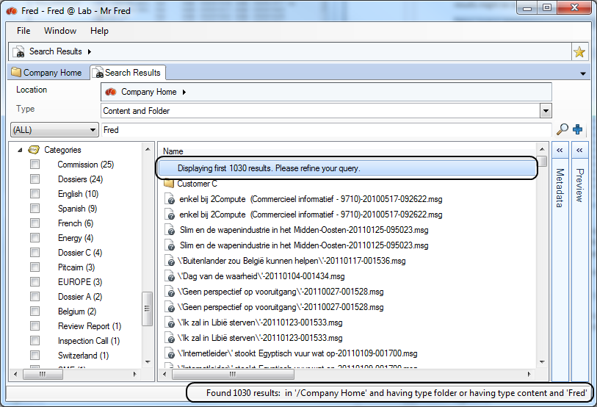

You can limit the time during which the search is executed, and the number of results that are evaluated, against access rights. If one of the limits set are met, the search ceases and the current result is evaluated against access rights and presented as the final search result.

A message is displayed with guidance on how to proceed to obtain a better search result.

While executing a result, Fred displays multiple messages:

* At the bottom left of the screen:  
  While searching  
  When result is found 
* In the search tab:  
  While searching  
    
  When the result is found  
  

If you launch a new search while the previous search is still running:

* You will receive a warning message  
  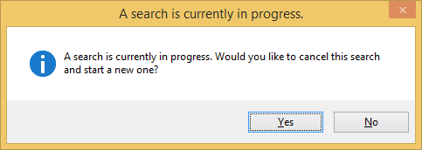
* If you confirm, then the running search will not be cancelled on the server, but the result will not be presented in Fred. Instead, Fred will present the result of the new search.

## Search in a part of the tree structure

If you want to limit your search to a part of the repository, you can set the folder in which you want to search. The search will be limited to the folder and its subfolders.

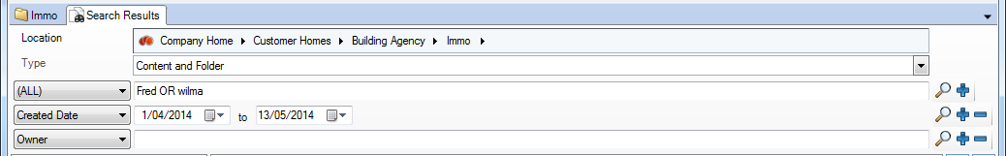

You can also select the Favourites folders as a location.

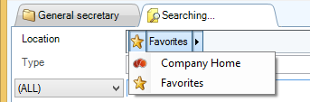 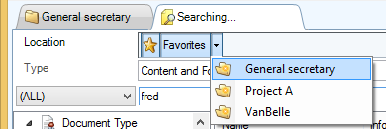

## Saved Search

You can save your current search by clicking on the star icon next to the search tab, usually in the upper right corner of the User Interface. This enables you to quickly perform the same search again in the future.

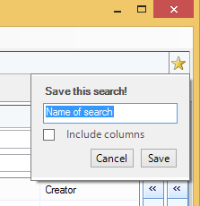 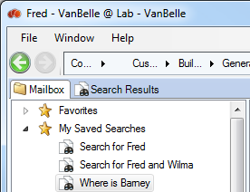

## Preview your search

When you select a document displayed in the result list of a search, the metadata is shown directly in the metadata pane as well as a preview of the selected file.

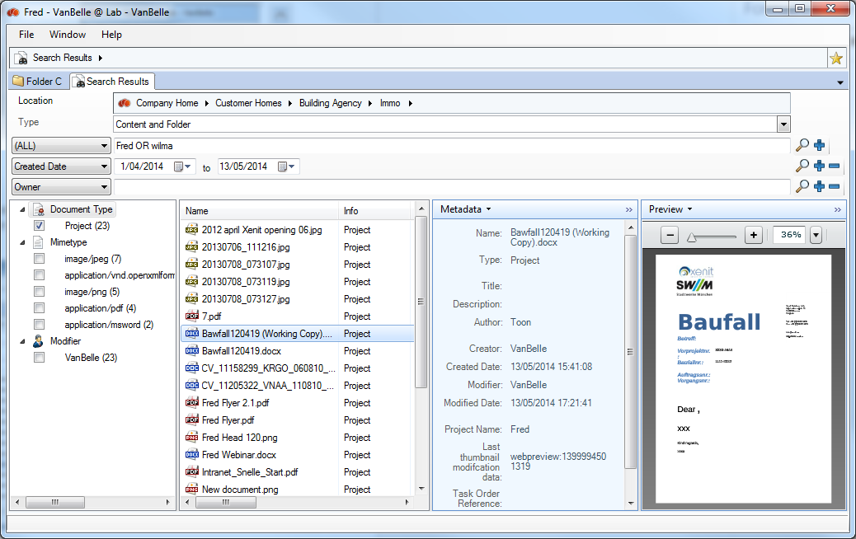

## Grouping on metadata values

You can group the search results on the values in one metadata field. Right click on the column header and select “Group by”.

Remove the grouping by deselecting the metadata field in the list.

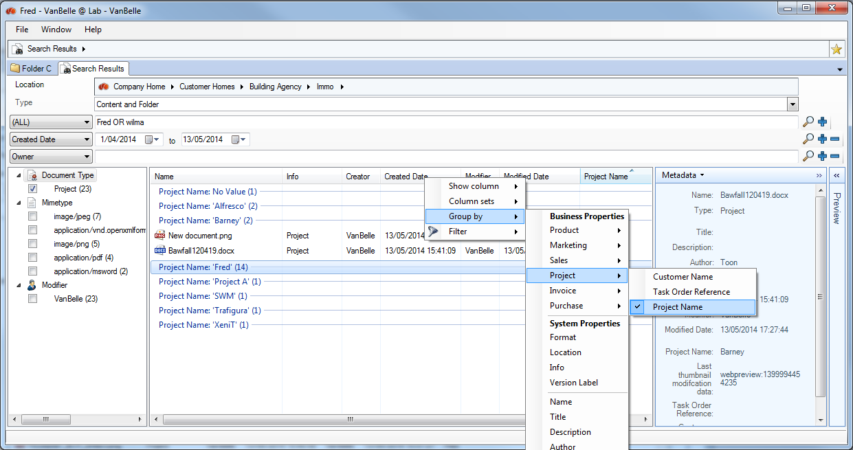

## Open file location

The search result is shown in a list view. Many of the file commands are available in the Search pane.

Clicking “Open File Location” will show you the folder or file selected in the tree structure. This will allow you, for example, to find a folder in which you have put a file, and add a new file to the same folder.

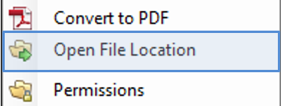

# Workflow

## Starting a workflow

In the repository, you can launch a workflow from one or more selected content items, whether they are files or folders. Starting a workflow generates a workflow task for the users assigned to the task.

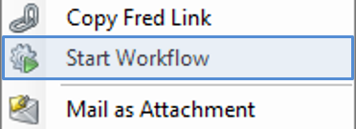

* Navigate the library’s folder structure to locate the item(s) you want to work with. These can be documents and/or folders
* Select the relevant item(s)
* Click Start Workflow
* The Start Workflow tab appears
* Expand the Workflow list and select the type of workflow you want to define

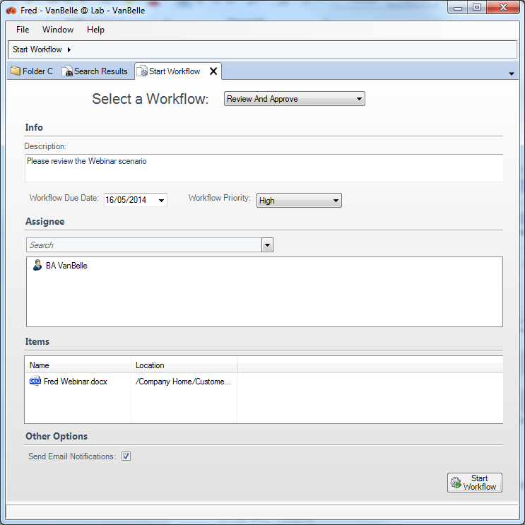

The following preconfigured workflows are available:

Adhoc

Allows you to assign a task to a single user.

Group Review & Approve

Allows you to set up, review and approve content, whilst assigning the workflow task to a single group.

Parallel Review & Approve

Allows you to set up, review and approve content, whilst assigning the workflow task to multiple users.

Pooled Review & Approve

Allows you to set up, review and approve content, whilst assigning the workflow task to multiple users. One user can take ownership of the task at a time, completing it or returning it to the pool, to then be claimed by another user associated with the task.

Review & Approve

Allows you to set up, review and approve content, whilstassigning the workflow task to a single user,

The appropriate workflow form displays where you enter the details of the workflow task being initiated. Required fields are marked with an asterisk (*).

* Provide the basic details for the workflow task in the Information section
  + In the Description field, describe what you want the recipient of the task to do, such as: “Please review the attached content”. This text displays in the My Tasks table of the workflow overview for this workflow task. This content should clearly explain to the user what they are expected to do with the related content item(s)
  + Click the icon to the right of the Workflow Due field to specify the completion date for the task
  + Select a Priority setting for the task
* You assign the task to either a user or a user group, depending on the type of workflow selected
  + In the Assignee section, type in the name of the user or group and press Enter. Fred will present you with a selection of users and groups that match your search criteria

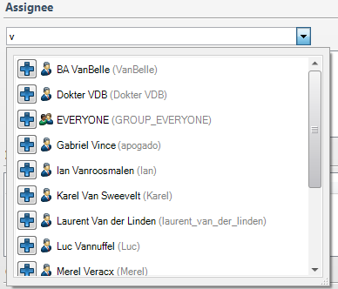

* + Click Select  to the left of a user or group to select it
  + For tasks with groups and multiple users, you must complete the Required Approval Percentage field. Indicate the percentage of reviewers that must approve the task in order for the entire workflow task to be considered complete
* Enable the Send Email Notifications setting in the Other Options section to have the application automatically send an email each time a task is assigned to a user as part of this workflow  
    
  Tasks generated by the workflow will appear in the user's My Tasks list in the Workflow Overview. An email is sent to the email address listed in the user's profile. If an address is not provided, no email will be sent.  
    
  For group and pooled tasks, every member of the selected group will receive the email notification:
* Click Start Workflow
* The workflow task is created. A record will appear in the My Tasks list and the Workflows I’ve Started list of the appropriate users

## Workflow overview

The workflow overview provides you with a view of the Tasks assigned to you and the workflows you have started.

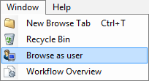

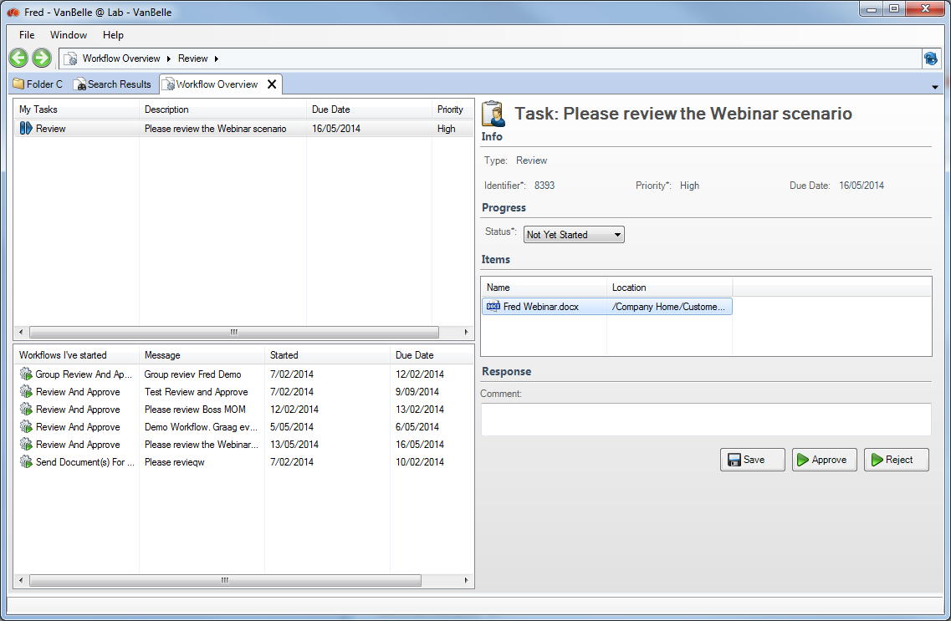

The left upper pane is a list of all actions that are assigned to you.

The left lower pane is a list of all workflows you have launched.

The right pane provides a detailed view of the task or the workflow you have selected on the left hand side.

## My Tasks

The My Tasks list lets you view and manage the tasks that are assigned to you. You can sort the list of tasks by clicking on the column header. Selecting a task will show the details of the task in the right hand pane.

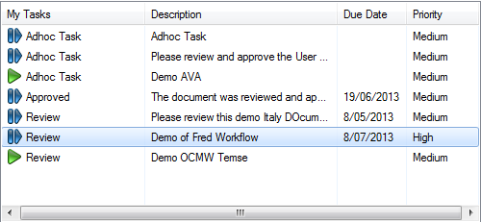

The summary provided for each task includes:

* Current status of the task
* Task type
* Task name
* Due date
* Priority

## Editing a task

Each task is your responsibility, and remains assigned to you until you manage it.

In the task list, locate the task you want to perform and select it. In the right hand pane, the details of the task are presented. The actions available on this page depend on the task type.

Manage the selected task in one or more of the following ways:

Update: If the task is in progress but not yet complete, you can change the task status and add a comment indicating your progress, then click Save and Close. The task remains assigned to you.

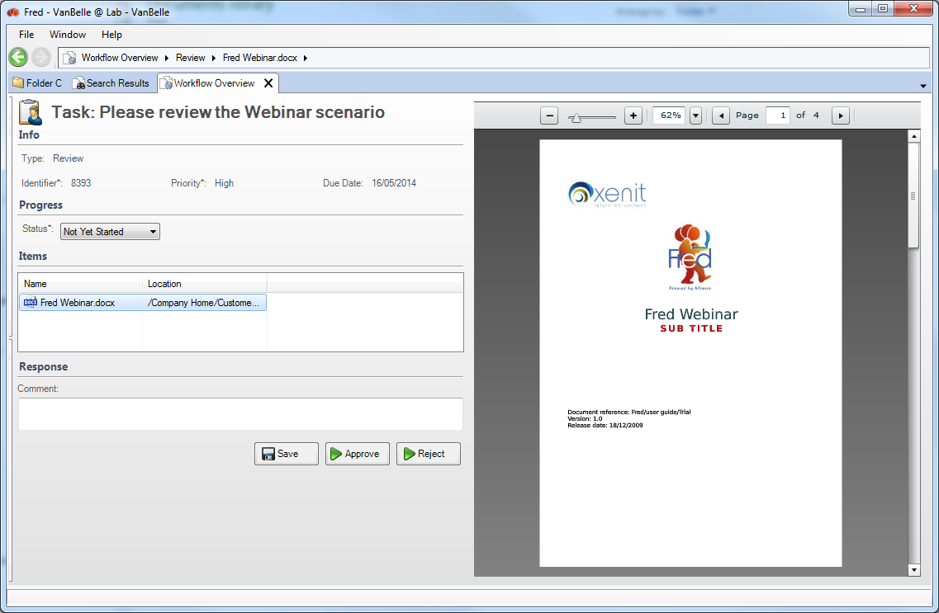

Approve or Reject: When you have completed a task, you can update the task status, add a comment indicating the work performed, and then click either Approve or Reject. The task returns to the user who started the workflow and no longer appears in your task list.

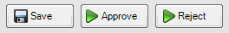

Claim: Click Claim to take responsibility for a pooled task. This action is available only for pooled tasks that are not yet assigned.

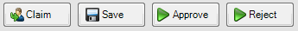

Release to Pool: Click Release to Pool to place a task back in the pool. The task then appears in the task list as Unassigned and can be claimed by another user. This action is available only for pooled tasks that are currently owned by you.

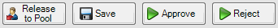

Task Done: Once a task is complete, it is returned to the user who started the associated workflow. Click Task Done to finish a task and remove it from your task list.

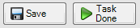

Once the selected action is complete, the task will be removed from the user’s My Task list. A new task will appear in the My Task list of the person that launched the workflow, to confirm that the workflow has been completed.

## Overview of the documents

It is possible to configure the metadata columns in the Items list and group linked documents based on a metadata field value. In the below example, an invoice and related purchase orders are presented to the person that needs to approve the invoice. You can, for example, show the Total Amount related to the documents.

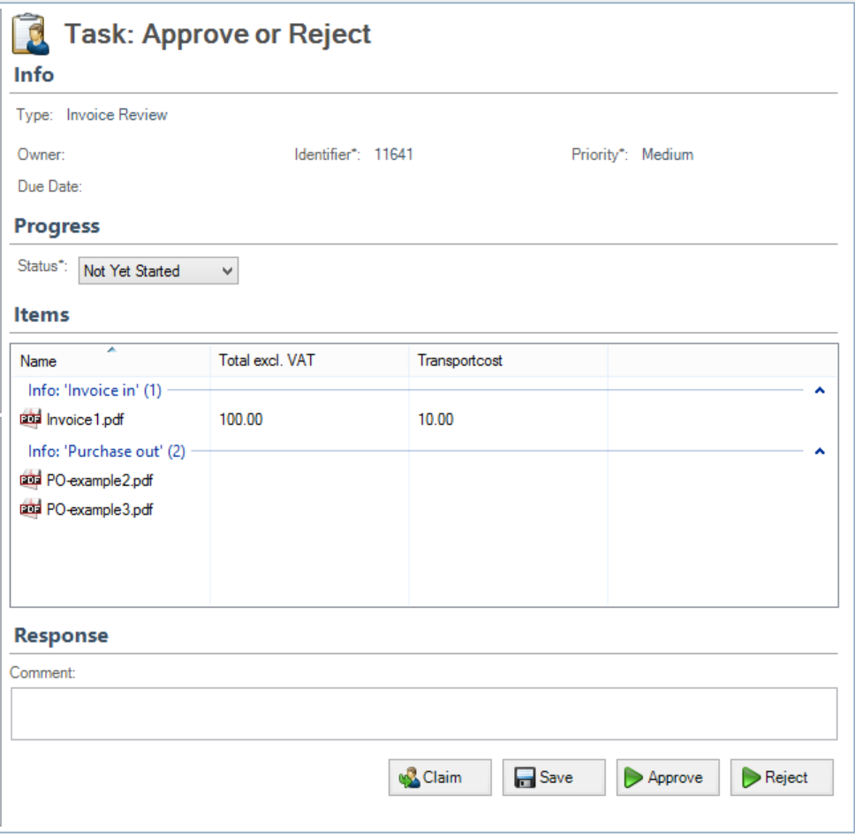

The system administrator can configure the columns and the grouping.

## workflows I’ve started

From the Workflows I’ve Started list, you can view the full details of a workflow, including: a workflow summary, details on the most recently completed task, and a summary of all tasks generated by the workflow.

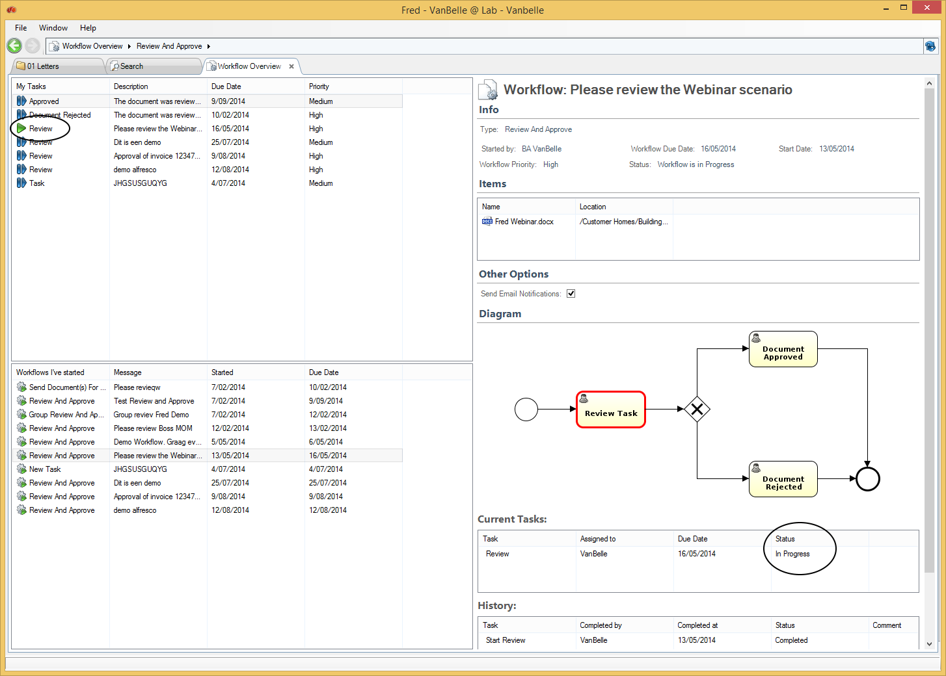

The summary provided for each workflow includes:

* Workflow type
* Workflow name
* Date started
* Due date

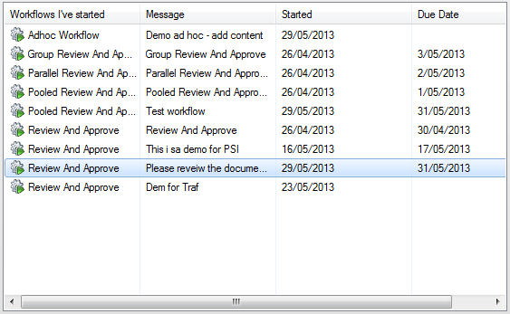

Viewing a workflow allows you to confirm that you have selected the correct one before you cancel it.

In the list Workflows I’ve Started, select the workflow you want to review in detail.

The Details page appears, displaying information for the selected workflow.

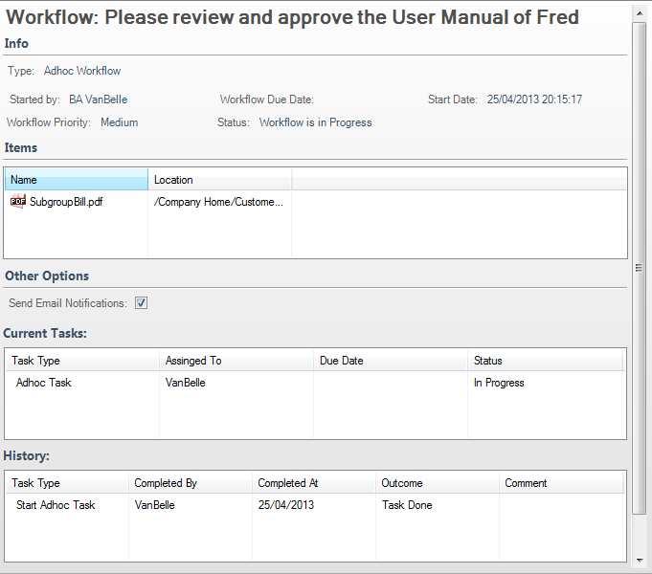

Current Tasks:

Overview of the open tasks related to this workflow. Clicking on a task in this list will provide you with a detailed view of the task.

To return to the Workflow Detail view, click on .

History:

Overview of the tasks that have been executed to date. Clicking on a task will provide you with a detailed view of the task.

To return to the Workflow Detail view, click on .

## Cancelling a workflow

Cancel an existing workflow when it is no longer required. This deletes all tasks related to the workflow.

In the workflow list, locate the workflow you wish to cancel. In the Workflow Details pane, click Cancel Workflow.

The selected workflow is cancelled and removed from the workflow list. All tasks related to the workflow are deleted, which removes them from the assignees’ task lists.

# Additional user functions

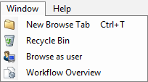

## New Browse Tab

You can open multiple Browser tabs. Each tab will describe the active folder in the tab. You can also use the shortcut CTRL+T to open a new tab.

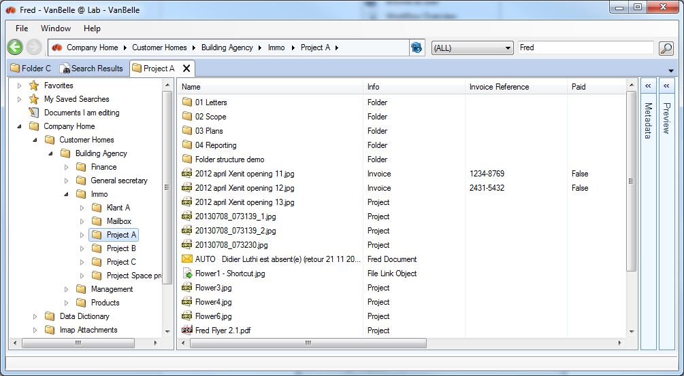

## Recycle bin

The recycle bin enables you to restore deleted files and folders, similar to the Windows Recycle Bin.

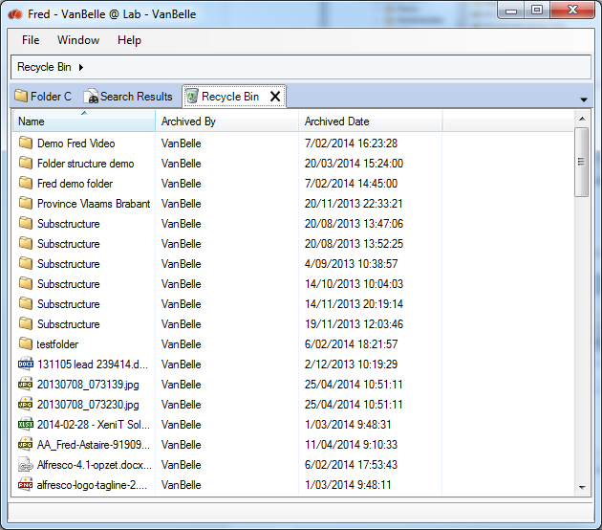

## Browse as user

Only the general Alfresco ECM Administrator will have following functionality available.

Administrators can impersonate another user. The administrator can see what a user can see to, for example, troubleshoot permissions.

* Open the Windows Menu and click the “Browse as user”-command and a Browse as user tab will open
* In the upper textbox, fill in the Alfresco username and click on “Switch User”
* The specified user has a minimum of consumer (=read) access to the folder structure and documents that appear



# Fred User Settings

Fred allows you to configure settings listed below. To change the settings, click on “File” and select “Open Settings”.

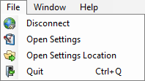

## General

Localization

* Fred will use, by default, the language set in Windows. You can set a specific language pack for the Fred user interface
* The Fred Working Directory is the folder used to download the working copies in the “Edit Offline” action
  + The checkbox ‘Clean up temporary files on disconnect’ activates the removal of temporary copies of downloaded files. As you continue to consult documents, temporary copies remain on your local drive and grow in volume
  + The checkbox ‘Ask to check-in working copies on disconnect’ activates a message box that will ask you to check-in all working copies when disconnecting from the repository. This is useful when you are working on two computers, and you want to move from one computer to the other

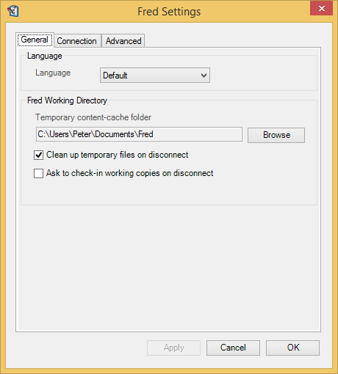

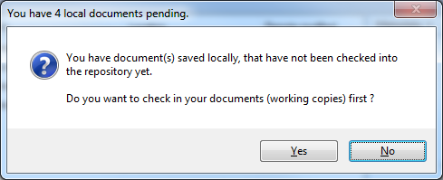

## Connection

Proxy settings

* Fred is enabled to handle proxy configuration. Contact your system administrator for more information

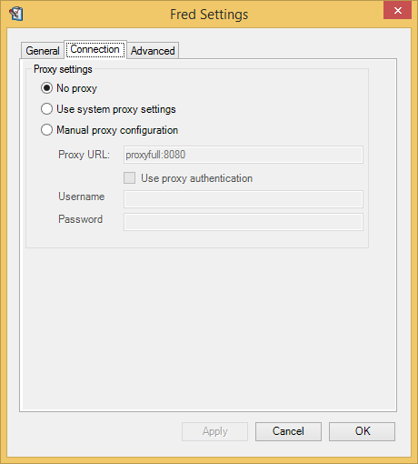

## Advanced

The settings in the advanced tab allow you to configure the behavior of the Fred window.

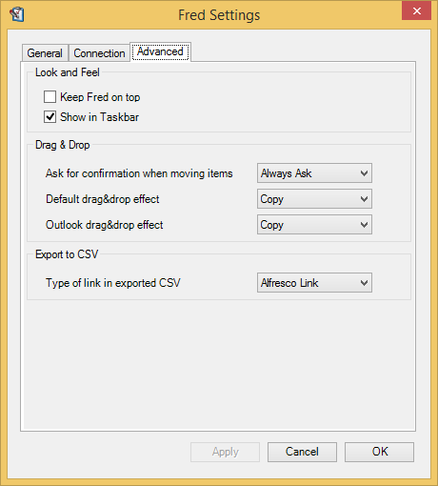

Look and Feel

Keep Fred on top: keeps the Fred window on top of all application windows. This will allow you to drag and drop files from another application directly into the Fred window.

Show in taskbar: presents a Fred tab in the Windows taskbar, not only in the system tray. Right mouse click on the icon  will provide a command menu.

Drag & Drop

Allows you to configure confirmation prompts and the default action that should take place when performing a drag and drop from the Windows desktop, Explorer, or the MS Outlook application.

**Export to CSV**When you export metadata from navigation details or search details, you can select to copy the Alfresco or Fred link of the object as the first column in the csv list. This enables you to jump to the object from the list.

# Enterprise configuration capabilities

Fred has multiple corporate configuration capabilities. The IT team can adapt the configuration files and modify the behavior in the user interface.

## Configuration of metadata panel

You can define which fields are presented in the Metadata View and Edit panes. You can also define the layout of the fields that are presented. Below is an example of how you can collapse a number of fields that might be less relevant in your day-to-day activities.

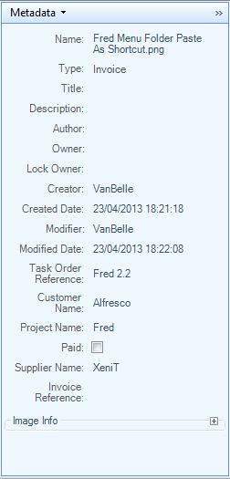 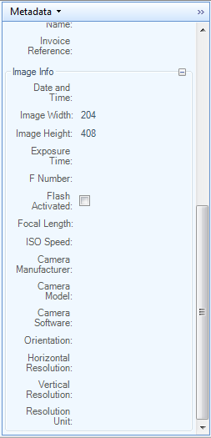

## ConfigurAtion of context menus

It is possible to adapt, reorder and extend the context menus in the Fred User Interface.

## Configuration of searchable properties

You can configure the list of fields that are made available in the Search field drop down.

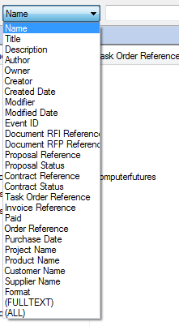

You can also configure which facets are presented in the search results.

## Configuration of metadata behavior at creation of documents

At the creation of a document from a template, a user can determine the behavior of the metadata. For example:

* metadata will have to be provided afterwards, or
* metadata will have to be provided before the creation. This metadata can then be used as field values in the document. For example: status of the document (draft, approved), date of the meeting

# General

## Showing 3rd party Alfresco Add-ons in Fred

It is possible to present 3rd party applications which are pre-integrated with Alfresco in the Fred User Interface. The 3rd party application must be installed and configured with Alfresco.

Following applications demonstrate the means to present the 3rd party application in Fred:

**PDF Digital Signature application**

The relevant command in the file menu will launch the application. The file is sent to the application, and a new tab is opened, providing a view of the document on the 3rd party application.

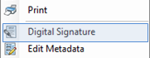

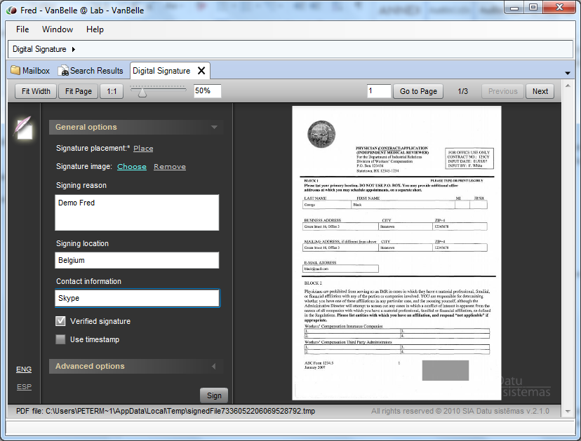

**Annotation tool aRender**

Annotations of the documents in a preview mode can be very handy in operational processes.

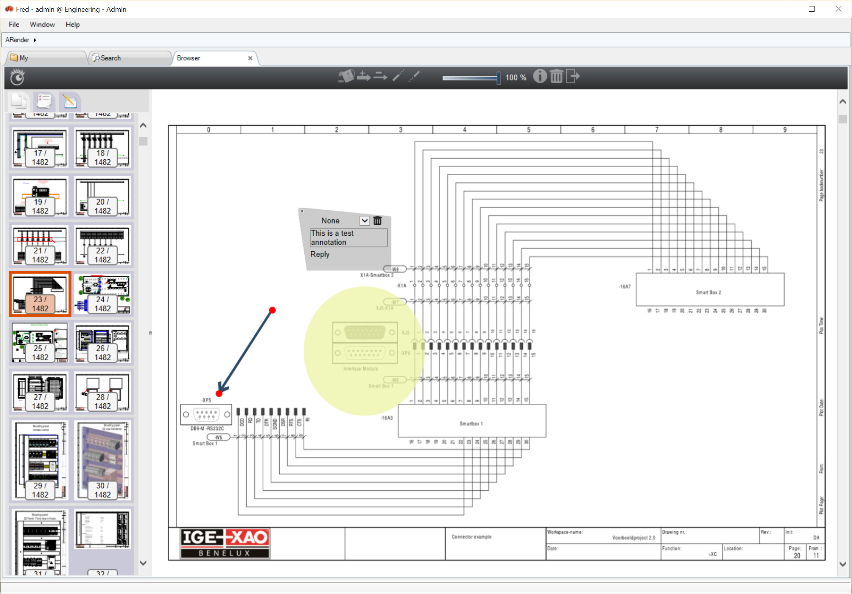

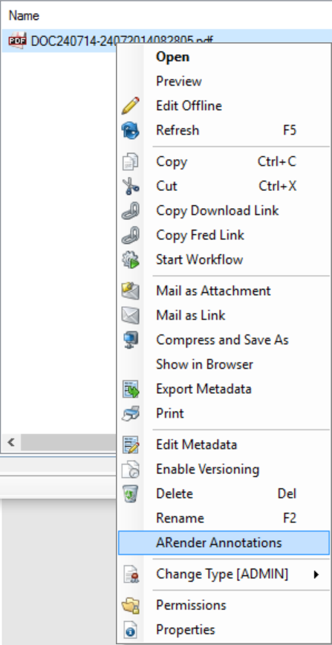

**DWG viewer of Formtek**

The Formtek EDM module, enables Alfresco to preview .dwg file. In this example, the dwg previews are shown in the preview pane.

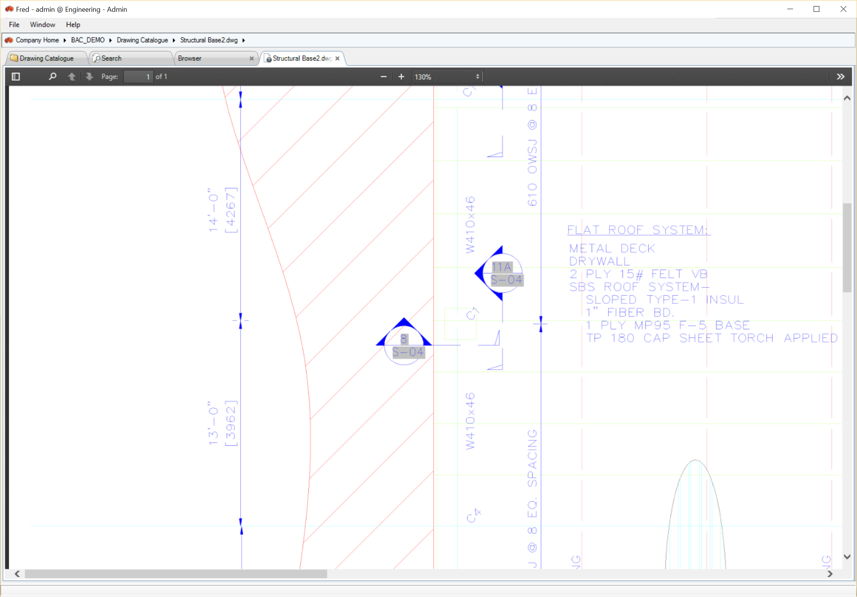

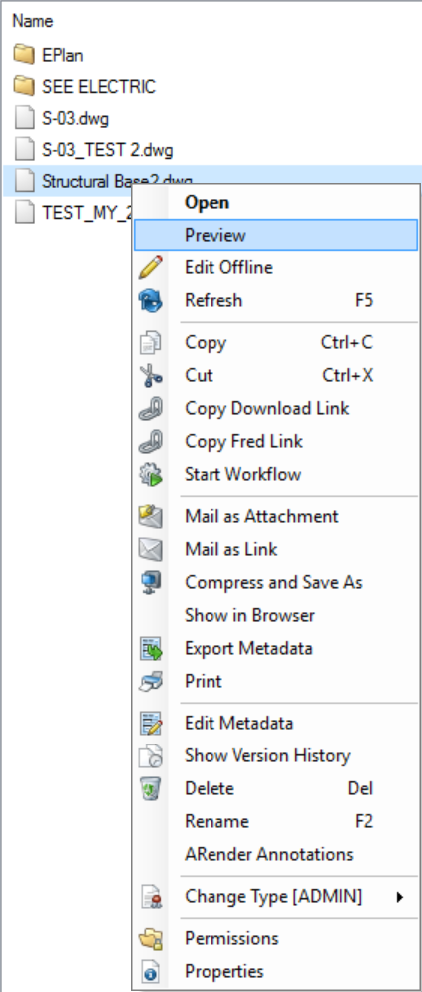

## local persistent caching

Fred provides persistent local caching of metadata. As you browse the repository, metadata is cached and remains available to obtain a faster navigation and search experience. The cache is refreshed regularly as you navigate and search through the repository or after a time period as set on the server. You can, at any time, force a refresh of the cache, by clicking F5 or the Refresh command.

# Reporting a problem

When a problem occurs, you can report it to your local IT helpdesk or to [support@xenit.eu](mailto:support@xenit.eu). The XeniT Fred team will be able to assist you more quickly if you are able to provide following information:

* A description of your desktop environment: Windows version, application version
* The Fred version
* A description of the problem
  + A screenshot is very helpful
* Log files: you can find the log files by “Files/Open settings location”
  + A list of log files appears. Attach the log files app-log4net.log and app-log4net.log1 to your report

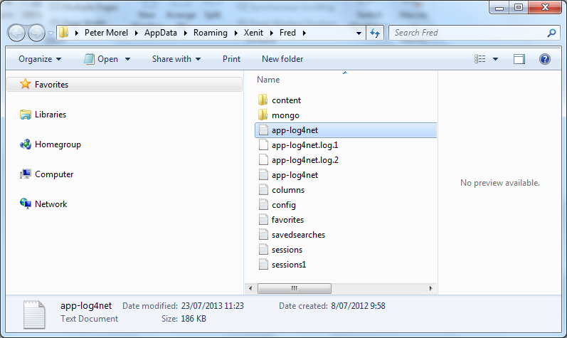

To help the user report a problem, a ‘Report A Problem’ command has been added to the Help menu.

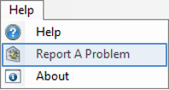

Clicking this command will open your default email application and attach the log files to it. You need to complete the description of the issue before sending it to your local IT desk or the XeniT Fred team.